An Accidental Guide to… | Accidental Intelligence 06 | 

VS Code and
Visual Studio
A pocket-sized guide to where GitHub Copilot’s agent setup lives, as of October 2026.
 Runs |  Written |  Checks |  Used |  Decided | Counted
 |  | Instructions file  page 3
 | Custom agent  page 3
 | 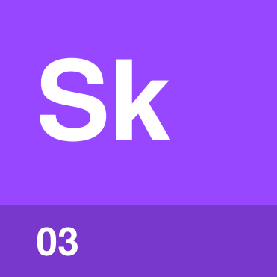 | Skill  page 4
 |  |  | 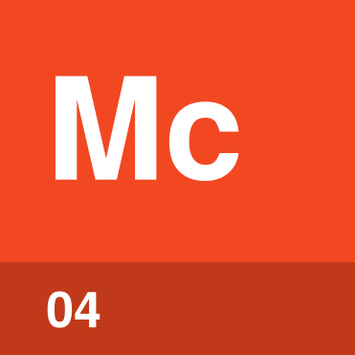 | MCP server  page 4
 |  |  |  | 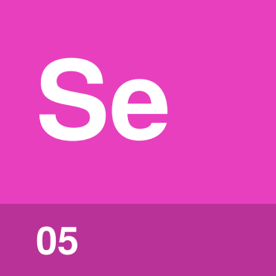 | Setting  page 5

What can you set up
in VS Code?
You can set up five things for GitHub Copilot’s agent in VS Code: instructions files, custom agents, skills, MCP servers and settings. Each can belong to a repo, to you or to your organization.
VS Code’s default harness, the Copilot harness, reads .github/ in the repo and ~/.copilot/ in your home folder. For the basics, see An Accidental Guide to: Agents, Harnesses, Skills, and Tools.
Instructions file | Rules the agent follows, always or for matching files.
Custom agent | A role with its own instructions, tools and model.
Skill | Steps the agent loads when a task needs them.
MCP server | A program that gives the agent more tools.
Setting | A switch or value that changes what VS Code does.

Instructions file | 

Identify by | copilot-instructions.md, AGENTS.md or a .instructions.md file.
What | An instructions file is text Copilot adds to your requests. See An Accidental Guide to: Agents, Harnesses, Skills, and Tools.
So what | Put rules you’d otherwise repeat in every chat here. An applyTo pattern makes a file apply only to matching files.

Field marks
Loads  When it applies. | Cannot  Settle a conflict.

Confused with |  Setting  An instructions file tells the agent how to work. A setting changes what VS Code does.

Custom agent | 

Identify by | A .agent.md file, or a name in the Agent dropdown.
What | A custom agent is a saved role with its own instructions, tools and model. See An Accidental Guide to: Agents, Harnesses, Skills, and Tools.
So what | Limiting a custom agent’s tools limits what it can change. Give each agent only the tools its job needs.

Field marks
Loads  When picked or started. | Cannot  Replace instructions.

Confused with | Chat mode  Chat mode is the old name for a custom agent, and a .chatmode.md file can be renamed to .agent.md.

Skill | 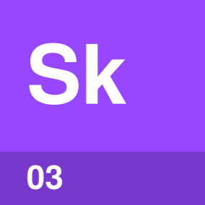

Identify by | A folder with a SKILL.md file whose name matches the folder.
What | A skill is a written procedure in a folder. Type /skill-name to run one. See An Accidental Guide to: Agent Skills.
So what | A skill’s steps take up no room until they’re needed. When a skill doesn’t run, check its description first.

Field marks
Loads  Description first. | Cannot  Add a tool.

Confused with | Prompt file  A prompt file (.prompt.md) is a saved prompt you run with /name. Only the Local harness runs them, so VS Code suggests a skill.

MCP server | 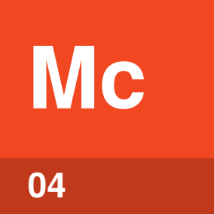

Identify by | An entry with a command or a URL in .mcp.json or ~/.copilot/mcp-config.json.
What | An MCP server is a program that gives the agent more tools. Search @mcp in Extensions to find one. See An Accidental Guide to: Model Context Protocol.
So what | A local MCP server runs code on your machine with your permissions. Add only servers you trust.

Field marks
Loads  When it connects. | Cannot  Act by itself.

Confused with | Extension  An extension adds features to VS Code itself. MCP servers install from the same view, for you or for the workspace.

Setting | 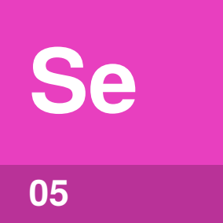

Identify by | A value in the Settings editor, your user settings or .vscode/settings.json.
What | A setting is a switch or value that changes how VS Code behaves. For example, chat.useAgentSkills turns skills on and off.
So what | When something works for a teammate and not for you, compare your settings. Your user settings apply in every repo.

Field marks
Loads  From every scope. | Cannot  Guide the agent.

Confused with | Policy  A policy is a setting an administrator makes for your organization. It wins over your own settings.

Where things live
The Copilot harness reads these places. Use the repo for what the team shares and your home folder for what’s only yours.
Thing | Scope | Location
 Instructions file | Repo | .github/copilot-instructions.md
 |  | AGENTS.md, from the root down to the working folder
 |  | .github/instructions/*.instructions.md
 | You | ~/.copilot/copilot-instructions.md
 |  | ~/.copilot/instructions/*.instructions.md
 | Organization | Copilot settings in your GitHub organization
 Custom agent | Repo | .github/agents/*.agent.md
 | You | ~/.copilot/agents/*.agent.md
 | Organization | agents/ in the organization’s .github-private repo
 Skill | Repo | .github/skills/
 |  | .agents/skills/
 | You | ~/.copilot/skills/
 |  | ~/.agents/skills/
 MCP server | Repo | .mcp.json
 | You | ~/.copilot/mcp-config.json
 | Organization | A registry of approved servers, set in GitHub
Setting | Repo | .vscode/settings.json
 | You | Your user settings.json
 | Organization | Policies set by an administrator

The Local harness also reads .vscode/mcp.json. The Claude harness reads .claude/ and ~/.claude/ instead.

How scopes combine
Instructions add up, and settings override.
Thing | When more than one scope has one
Instructions file | Every file that applies is added. None takes priority.
Custom agent | The selected agent’s instructions win a conflict.
MCP server | Give each server its own name. Your organization can limit which ones run.
Setting | Default, then User, then Workspace, and the later one wins. An administrator’s policy wins over all three.

Tip. When two instructions files disagree, change them so they agree. The load order won’t settle it.

What’s different
in Visual Studio
Thing | In Visual Studio
Instructions file | .github/copilot-instructions.md and .github/instructions/*.instructions.md. In Visual Studio 2026, personal instructions go in %USERPROFILE%/copilot-instructions.md.
Custom agent | .github/agents/*.agent.md, or %USERPROFILE%\.github\agents for your own. Version 18.4 or later.
Skill | The same folders as VS Code. Version 18.5 or later.
MCP server | %USERPROFILE%\.mcp.json, then .vs\mcp.json, .mcp.json, .vscode\mcp.json and .cursor\mcp.json in the solution folder.
Setting | Tools › Options › GitHub › Copilot, where a checkbox turns instructions files on.

Visual Studio doesn’t list AGENTS.md as supported, so put rules both editors need in .github/copilot-instructions.md.

Same thing elsewhere
Copilot CLI uses the same Copilot harness, so it reads the same .github/ and ~/.copilot/ folders.
Thing | In the other tools
Instructions file | Claude Code: CLAUDE.md. Codex: AGENTS.md. Claude Desktop: project instructions.
Custom agent | Claude Code: .claude/agents/. Codex: .codex/agents/.
Skill | Claude Code: .claude/skills/. Codex: .agents/skills/. Claude Desktop: Customize › Skills.
MCP server | Claude Code: .mcp.json. Codex: ~/.codex/config.toml. Claude Desktop: Customize › Connectors.
Setting | Claude Code: .claude/settings.json. Codex: ~/.codex/config.toml.

Each has its own guide: An Accidental Guide to: Claude Code, An Accidental Guide to: Claude Desktop, An Accidental Guide to: GitHub Copilot CLI and An Accidental Guide to: OpenAI Codex.

Sources
These public pages were checked on 22 October 2026.
Choose an Agent Harness
VS Code · code.visualstudio.com/docs/agents/run/agent-harnesses
Custom instructions
VS Code · code.visualstudio.com/docs/copilot/customization/custom-instructions
Custom agents
VS Code · code.visualstudio.com/docs/agent-customization/custom-agents
Agent skills
VS Code · code.visualstudio.com/docs/agent-customization/agent-skills
MCP servers
VS Code · code.visualstudio.com/docs/agent-customization/mcp-servers
User and workspace settings
VS Code · code.visualstudio.com/docs/configure/settings
Customize chat responses
Microsoft Learn · learn.microsoft.com/visualstudio/ide/copilot-chat-context
Custom agents in Visual Studio
Microsoft Learn · learn.microsoft.com/visualstudio/ide/copilot-specialized-agents
MCP servers in Visual Studio
Microsoft Learn · learn.microsoft.com/visualstudio/ide/mcp-servers
Customization cheat sheet
GitHub Docs · docs.github.com/en/copilot/reference/customization-cheat-sheet
Claude Code settings
Anthropic · code.claude.com/docs/en/settings
Use Skills in Claude
Anthropic · support.claude.com/en/articles/12512180
Codex configuration basics
OpenAI · learn.chatgpt.com/docs/config-file/config-basic


An Accidental Guide to…
VS Code and Visual Studio
A pocket-sized guide to where GitHub Copilot’s agent setup lives, as of October 2026.
Written and reviewed by a person. AI does the grunt work. Set in TeX Gyre Heros and Newsreader.
Leave a star: accidental.info/star

