An Accidental Guide to… | Accidental Intelligence 11 | 

Specs and
Reviews
A pocket-sized guide to agreeing on work as a team and checking when it’s done.
 Runs |  Written |  Checks | Used |  Decided | Counted
 |  | Spec  page 4
 |  | Work item  page 4
 | 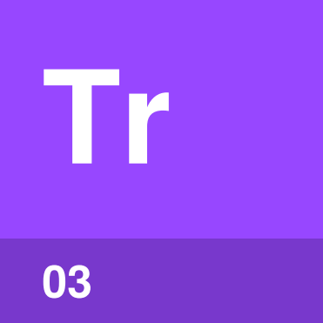 | Tracker  page 5
Acceptance criteria  page 5 |  |  |  | 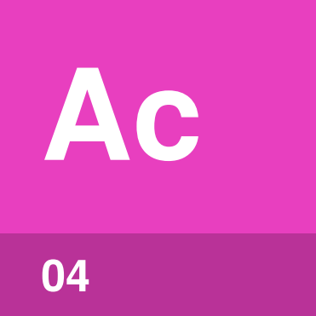
 |  | 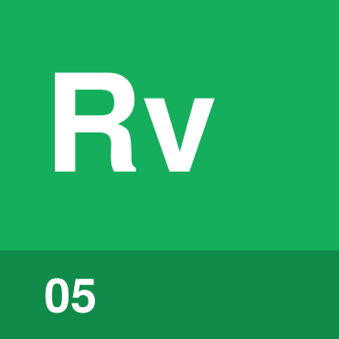 | Review  page 6

How does work get
from an idea to done?
When several people share the work on one thing, they need to agree on what they’re making, who is doing which part and when each part is finished. If your experience of a team is one person doing most of the heavy lifting, you may not have needed much of this. Once the work is shared, a spec, work items, a tracker, acceptance criteria and reviews keep everyone on the same page.
You define the result in a spec, split it into work items, and keep them in a tracker. Before work starts, you agree on acceptance criteria, so the person doing it and the reviewer use the same test.
Spec | What you want built and why.
Work item | One piece of work one person can finish.
Tracker | The shared list of work, owners and statuses.
Acceptance criteria | Conditions the finished work must meet.
Review | Someone else checks, then approves or requests changes.

How do the parts fit together?
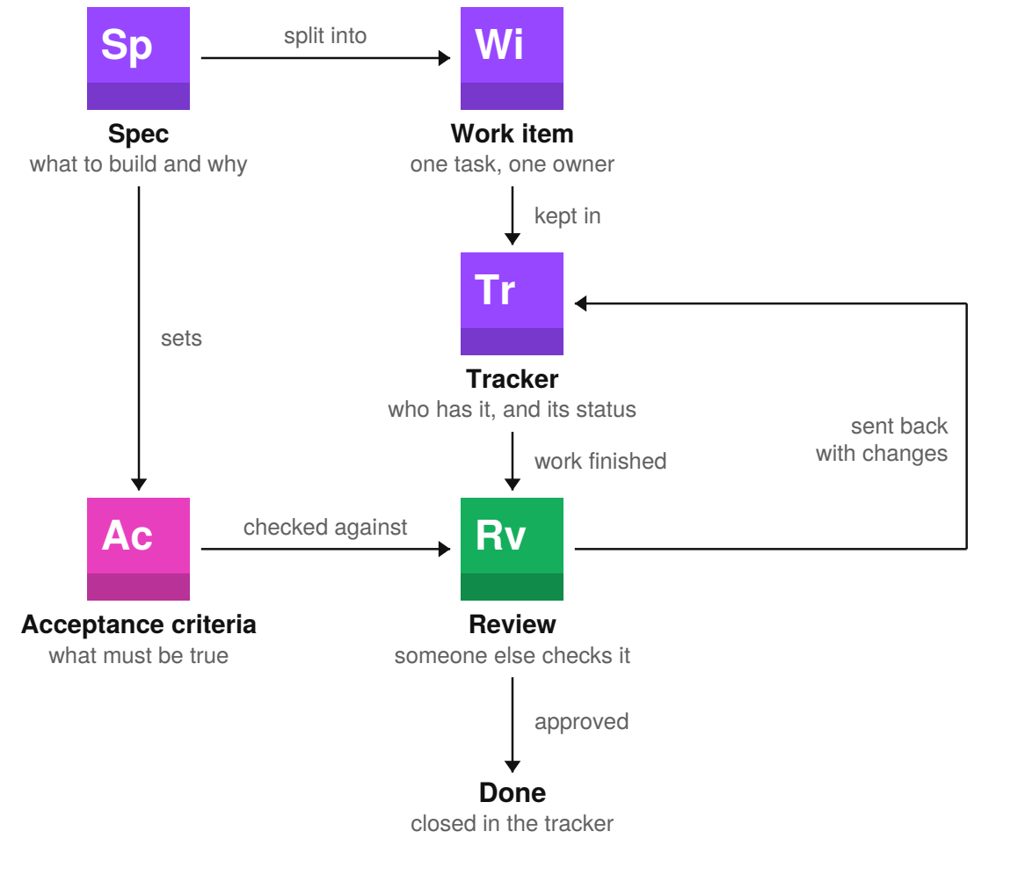
Every step updates the tracker, so anyone can see who has each item and where it stands. Requested changes send the item back to in progress.
Tip. When review keeps sending work back, check the acceptance criteria and the spec before the work itself. One of them may be unclear.

Spec | 

Identify by | Requirements, a design or a brief in a shared document.
What | A spec says what you want built and why. The spec also says what the work covers and leaves out.
So what | A shared spec keeps everyone working toward the same result. The people asking and those doing the work agree before it is split up.

Field marks
Owned by  The person asking for the work. | Kept in  A shared document. | Cannot  Cover what nobody wrote down.

Confused with |  Work item  A spec describes the whole result and why it’s wanted. A work item is one piece of that work, sized for one person.

Work item | 

Identify by | A task, ticket, issue or story in a tracker.
What | A work item is one piece of a larger job, small enough for one person to finish in days. The item links to the spec and holds its acceptance criteria.
So what | Small work items show progress and problems early. Problems get fixed while they’re still small.

Field marks
Owned by  One person. | Kept in  The tracker. | Cannot  Replace a missing spec.

Confused with | Milestone  A milestone is a date or release for finishing several items, not work itself.

Tracker | 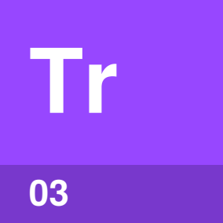

Identify by | A shared tool such as GitHub Issues, Jira or a spreadsheet.
What | A tracker is the shared list of work items. Each item has an owner and a status.
So what | A current tracker makes progress visible. Anyone can see who has what, what is stuck and what is done.

Field marks
Owned by  Everyone using it. | Kept in  One shared tool. | Cannot  Judge the result.

Confused with | Backlog  A backlog holds unstarted work. A tracker also holds work in progress, review or done.

Acceptance criteria | 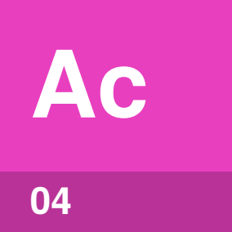

Identify by | Short statements in the work item, each one true or false.
What | Acceptance criteria state what must be true for a work item to be accepted. For example, a user can reset a password from the sign-in page.
So what | Agreed criteria give the person doing the work and the reviewer the same test. Set them before work starts.

Field marks
Owned by  The person asking for the work. | Kept in  The work item. | Cannot  Catch an unwritten case.

Confused with | Definition of done  Acceptance criteria apply to one item. A definition of done is a checklist for every item.

Review | 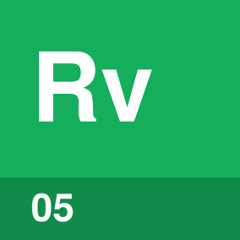

Identify by | A code review, design review or sign-off in the work item.
What | A review checks work against its acceptance criteria. The reviewer, who didn’t do the work, approves it or asks for specific changes.
So what | A second person catches a missed condition or mistake. Mistakes are hard to see in your own work.

Field marks
Owned by  The reviewer. | Kept in  The work item. | Cannot  Find every problem.

Confused with | Approval  A review is the check, and approval is the decision it can end in. If someone approves work without checking it, there was no review.

Easy to mix up
Spec or acceptance criteria? | The spec covers the whole result. Acceptance criteria say what one finished item must meet.
Review or testing? | Testing checks behavior. Review lets another person judge the result and the evidence.
Done or released? | Done means the item was accepted. Released means its result has reached its users.

One work item,  start to finish | 

The work item keeps its owner, status, criteria and review together in the tracker.
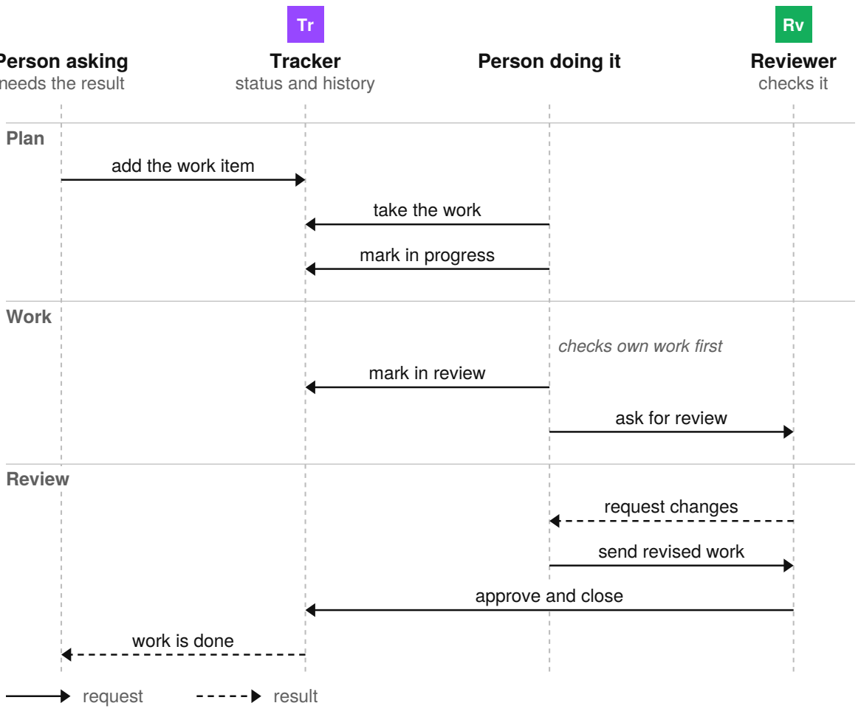
Approval closes the item. A request for changes sends it back to in progress with the reviewer’s comments, then back to review.

Sources
These public sources were checked in October 2026.
Ken Schwaber and Jeff Sutherland, The Scrum Guide
November 2020 · scrumguides.org/scrum-guide.html
Agile Alliance, Agile Glossary
October 2026 · agilealliance.org/agile101/agile-glossary/
GitHub Docs, Issues
October 2026 · docs.github.com/en/issues
Google, Engineering Practices: Code Review
October 2026 · google.github.io/eng-practices/review/


An Accidental Guide to…
Specs and Reviews
A pocket-sized guide to agreeing on work as a team and checking when it’s done.
Written and reviewed by a person. AI does the grunt work. Set in TeX Gyre Heros and Newsreader.
Leave a star: accidental.info/star

