An Accidental Guide to… | Accidental Intelligence 09 | 

Plugins,
Connectors, and
Marketplaces
A pocket-sized guide to the names for things you add to a coding agent or AI app.
 Runs |  Written |  Checks |  Used | Decided | Counted
 |  |  |  | Tools  page 4
 | 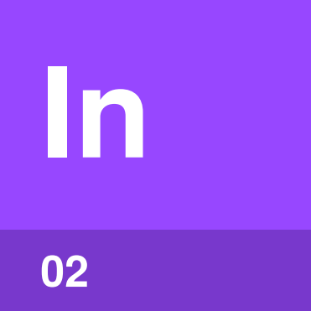 | Instructions  page 5
 | Hooks  page 6
 |  |  | 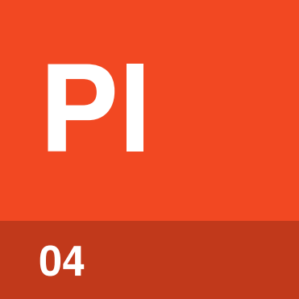 | Packages  page 6
 | 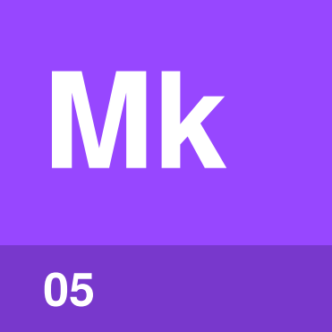 | Marketplaces  page 7

What are all these things?
Every product lets you add things to a coding agent or AI app, but each product uses its own names and the same word can mean different things. Every one of them is one of five kinds of thing: tools, instructions, hooks, packages and marketplaces.
Claude apps means claude.ai and the Claude Desktop app. An Accidental Guide to: Agents, Harnesses, Skills, and Tools explains the basic terms.

The map
Each colored line is one kind of thing, and each stop is a name you’ll see.
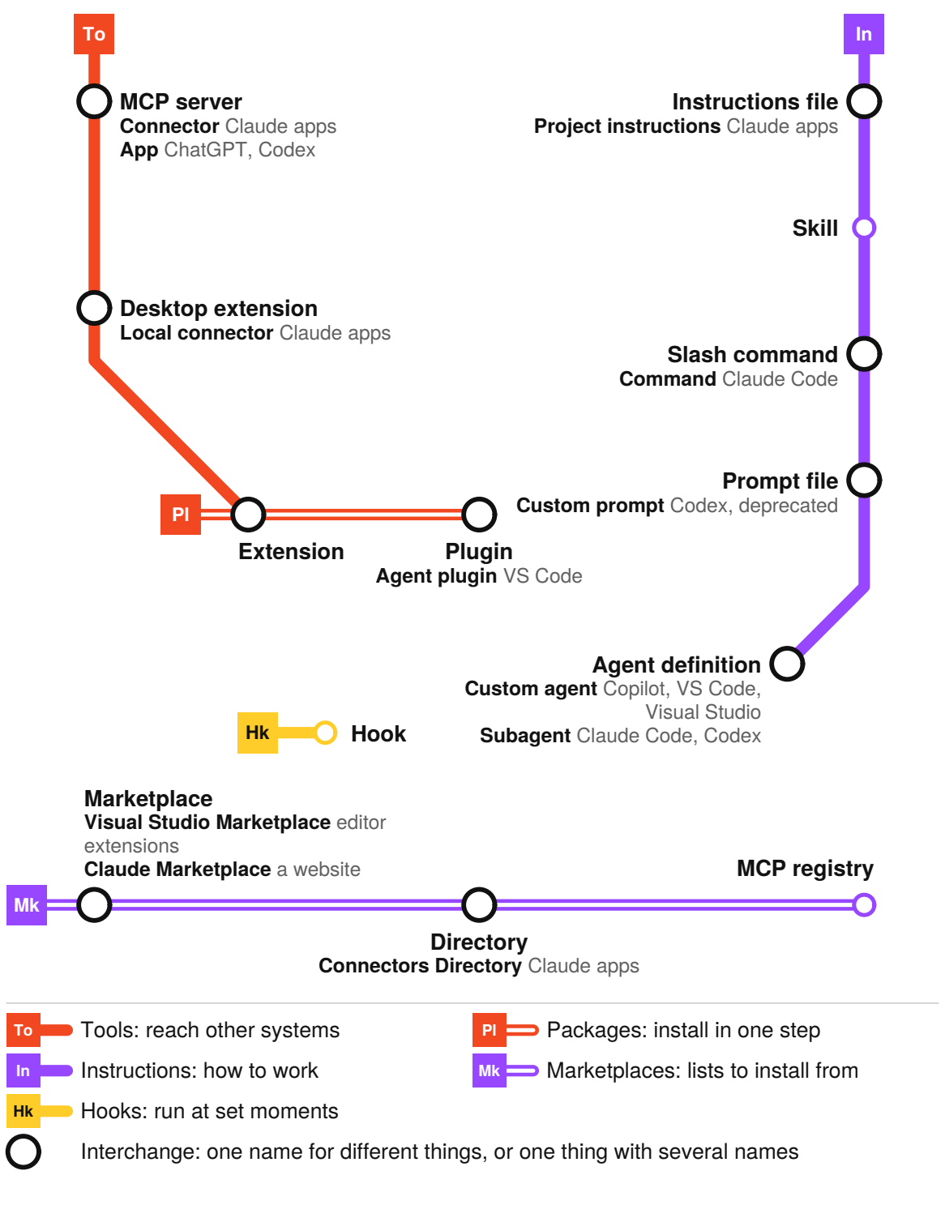
Tip. Find a new word on its line, then check the product because names can overlap.

Tools | 

What | Most tools you add come from MCP servers, which some products call connectors, apps or extensions. See An Accidental Guide to: Agents, Harnesses, Skills, and Tools.
So what | One MCP server works in all these products, so ask for one when the agent needs a new system. See An Accidental Guide to: Model Context Protocol.

Names
 MCP server | A program that gives the agent tools
Connector | What Claude apps call an MCP server. OpenAI says app.
Desktop extension | A local MCP server in one file, for Claude Desktop
Extension | A tool module in Copilot CLI, or a VS Code add-on that adds tools

Confused with |  Instructions  A tool reaches another system. Instructions say when to use it.

Instructions | 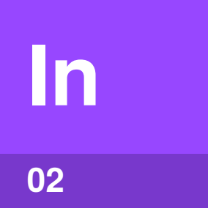

What | Instructions tell the agent how to work. An instructions file loads every session. See An Accidental Guide to: Agents, Harnesses, Skills, and Tools.
So what | Put rules in an instructions file. Steps for one kind of task go in a skill, which loads only when a task needs it. See An Accidental Guide to: Agent Skills.

Names
Instructions file | Read every session, such as AGENTS.md or CLAUDE.md. Claude apps say project instructions.
Skill | Loaded when the task matches or when you type /name
Prompt file | A saved prompt you run with /name
Custom agent | Sets up a sub-agent. Claude Code and Codex say subagent.

Confused with |  Hooks  Instructions guide the model. A hook runs every time, even if the model skips an instruction.

Hooks | 

What | A hook is a command the harness runs at a set moment, such as after every edit. The model does not choose whether it runs.
So what | Use a hook for anything that must happen every time. A check before each commit is one example.

Names
Hook | A command the harness runs on an event
Hook | In Claude apps, only inside a plugin, in Cowork

Confused with | Tools  A tool runs when the model calls it. A hook runs when its event happens.

Packages | 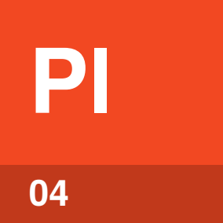

What | A plugin is a package of skills, agent definitions, hooks and MCP servers. You install it in one step.
So what | Copilot CLI, VS Code and Codex read Claude Code’s plugin files. Each loads only the parts it supports.

Names
 Plugin | A folder of agent parts installed as one package
Agent plugin | VS Code’s name for a plugin
Extension | An add-on for the VS Code or Visual Studio editor
IDE extension | Claude Code or Codex itself, inside the editor

Confused with |  Marketplaces  A plugin is a package you install. A marketplace tells your product where to find it.

Marketplaces | 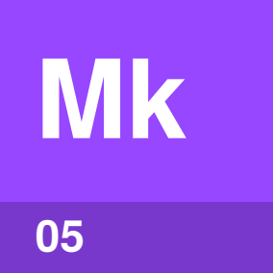

What | A plugin marketplace is a marketplace.json catalog in a Git repository. Add it, then install plugins by name.
So what | Anyone can publish a marketplace, so adding one means trusting whoever runs it. Anthropic reviews the plugins in its directory, but not ones added from a marketplace.

Names
Marketplace | A list of plugins kept in a Git repository
Directory | A list the company reviews, such as the Connectors Directory
MCP registry | GitHub’s list of MCP servers
Visual Studio Marketplace | The store for VS Code and Visual Studio extensions

Confused with | Visual Studio Marketplace  The Visual Studio Marketplace is a store for editor extensions, and Claude Marketplace is a website. Neither one is a plugin marketplace.

Which product uses which word
These are the words each product uses, and what they mean there, as of October 2026. No means the product’s documentation doesn’t use the word.
Word | Claude Code | Claude apps | Copilot CLI | VS Code | Visual Studio | Codex
MCP server | yes | as connector | yes | yes | yes | yes
Connector | from claude.ai | MCP server | no | no | no | inside plugins
Extension | harness in an editor | local MCP server | tool module | editor add-on | editor add-on | harness in an editor
Instructions file | CLAUDE.md | project instructions | yes | yes | yes | AGENTS.md
Prompt file | merged into skills | no | no | Local harness only | yes | deprecated
Custom agent | subagent | Cowork only | yes | yes | yes | subagent
Hook | yes | Cowork only | yes | preview | no | yes
Plugin | yes | yes | yes | agent plugin | no | not in the IDE
Marketplace | plugin list | plugin list | plugin list | both kinds | extension store | plugin list

Each product has its own guide: An Accidental Guide to: Claude Code, An Accidental Guide to: Claude Desktop, An Accidental Guide to: GitHub Copilot CLI, An Accidental Guide to: OpenAI Codex, and An Accidental Guide to: VS Code and Visual Studio.

Sources
These public sources were checked in October 2026.
Anthropic, Claude Code: plugins
October 2026 · code.claude.com/docs/en/plugins
Anthropic, Claude: plugins
October 2026 · claude.com/docs/plugins/overview
Anthropic, Claude: connectors
October 2026 · claude.com/docs/connectors
GitHub, Plugins for GitHub Copilot
October 2026 · docs.github.com/en/copilot/concepts/customizations/plugins
Microsoft, Agent plugins in VS Code
October 2026 · code.visualstudio.com/docs/agent-customization/agent-plugins
Microsoft, Use MCP servers to extend GitHub Copilot in Visual Studio
October 2026 · learn.microsoft.com/en-us/visualstudio/ide/mcp-servers
OpenAI, Plugins
October 2026 · learn.chatgpt.com/docs/plugins
OpenAI, Plugin controls
October 2026 · learn.chatgpt.com/docs/enterprise/apps-and-connectors


An Accidental Guide to…
Plugins, Connectors, and Marketplaces
A pocket-sized guide to the names for things you add to a coding agent or AI app.
Written and reviewed by a person. AI does the grunt work. Set in TeX Gyre Heros and Newsreader.
Leave a star: accidental.info/star

