An Accidental Guide to… | At the table 03 | 

Ordering Wine
for the Table
A pocket-sized guide to ordering without knowing every name.
 Runs |  Written |  Checks |  Used |  Decided |  Counted
 |  | Wine list  page 4
 |  |  | 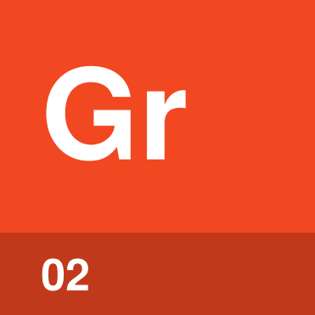 | Grape  page 4
Dry  page 5 |  |  |  |  | 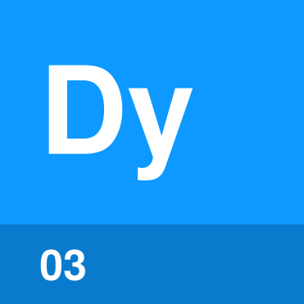
 |  |  |  | 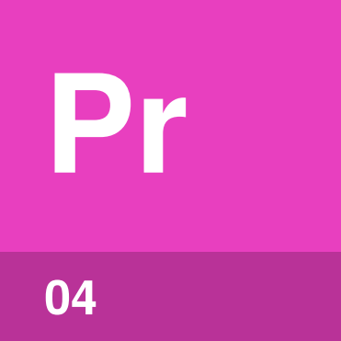 | Price  page 5
 |  | 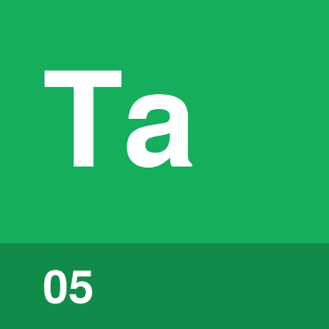 | Taste  page 6

How do you order
wine for the table?
Pick a price, then ask the server for help. Say what you’re eating and what you like. You don’t need to recognize every name on the list.
Once you know five words, you can order without pretending to know more than you do.
Wine list | The restaurant’s menu of wines and prices.
Grape | The variety a wine is made from.
Dry | A wine with no sugar you can taste.
Price | What the restaurant charges for a bottle or glass.
Taste | A small pour used to check for faults.

How does
ordering go?
Start with a price. The server can narrow the list from there.
Pick a price | Decide what you’ll spend per bottle before reading any names.
Open the list | Note the whites, reds and sparkling wines in your price band.
Ask the server | Say what you’re eating, your price band, and whether you like light or full, dry or a little sweet.
Order | Pick from the server’s suggestions, or name the wine you chose.
Check the label | Make sure the producer, wine and year match what you ordered.
Taste | Smell and sip the small pour to check that the wine isn’t faulty.
Pour for the table | Nod when the wine isn’t faulty, and the server will pour it.

Tip. A regular 750 ml bottle holds about five standard drinks. Allow about one bottle for every five glasses you expect.

Wine list | 

Identify by | A separate menu, or pages at the back of the main menu.
What | A wine list is the restaurant’s menu of wines and prices. Some wines are sold by the glass as well as the bottle.
So what | The prices give you a place to start. Pick your range first, then look at the names.

Field marks
Rule of thumb  Start with the numbers. | Watch for  Names you feel obliged to know.

Confused with | Wines by the glass  Wines by the glass are sold one glass at a time. By the glass suits a table whose dishes need different wines.

Grape | 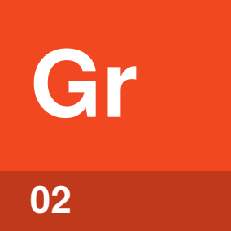

Identify by | A name such as Pinot Noir or Chardonnay.
What | A grape is the variety a wine is made from. The grape helps set a wine’s body, how heavy and rich it tastes.
So what | A few names cover a lot. Pinot Noir is usually a light red and Cabernet Sauvignon a full one, while Chardonnay is often a full white.

Field marks
Rule of thumb  Choose by body. | Watch for  Place names instead of grapes.

Confused with | Region  Some wines are listed by place, such as Chablis or Rioja. Ask the server which grape and style a place name means.

Dry | 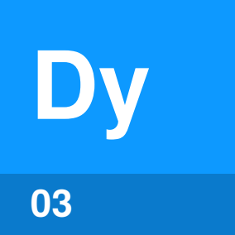

Identify by | The word on a list or label, or a question from the server.
What | Dry means the wine isn’t sweet. All the sugar you could taste has turned into alcohol.
So what | Dry tells the server how much sweetness you want. Ask for off-dry if you’d like a little, as in many Rieslings.

Field marks
Rule of thumb  Dry means not sweet. | Watch for  A drying feel is tannin.

Confused with | Dry mouthfeel  A dry wine isn’t sweet. A wine can also feel drying in your mouth, which comes from tannin, not sugar.

Price | 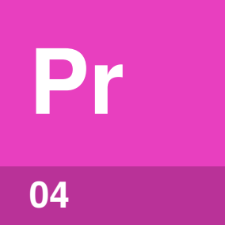

Identify by | The column of numbers beside the wines.
What | Price is what the restaurant charges for a bottle or glass. Markups run from 50 to 400 percent and vary across the list.
So what | A price band lets the server rule out most of the list. Say it plainly when you ask for help.

Field marks
Rule of thumb  Give a price band. | Watch for  Keeping your budget secret.

Confused with | Second-cheapest bottle  The second-cheapest bottle has a reputation as the worst deal. In one study of 235 London wine lists from 2015, its markup was on average below the next four wines up in price.

Taste | 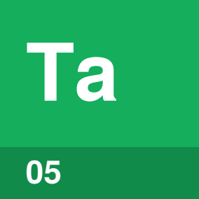

Identify by | The small pour the server gives the host.
What | A taste is the small pour you use to check the wine isn’t faulty. Corked wine smells musty, like wet cardboard.
So what | You’re checking the bottle, not your choice. If the wine smells musty, mouldy or flat, ask for another bottle.

Field marks
Rule of thumb  Smell, sip, then nod. | Watch for  Musty, mouldy or flat.

Confused with | Liking it  The taste is for faults, not your liking. If a bottle has no fault and you don’t like it, you can still ask kindly about another.

Common questions
Do I have to order right away? | No. Take your time. A glass of something sparkling to start buys a few minutes.
Glass or bottle? | By the glass helps when the table’s dishes are very different. For a large table, order a few bottles.
Where’s the good value? | Look for less familiar regions and grapes. In the London study, percentage markups were highest on mid-range wines.
Do I smell the cork? | No. Little can be learned from it, and presenting the cork is mostly for show.

Sources
These public sources were checked in October 2026.
Wine Spectator, What is “dry” wine?
July 2022 · winespectator.com/articles/what-is-dry-wine-aren-t-all-wines-wet
Wine Spectator, What is an “off-dry” wine?
August 2018 · winespectator.com/articles/what-is-off-dry-wine-56827
Wine Folly, What Is Wine Body
February 2025 · winefolly.com/tips/what-is-wine-body-and-how-to-taste-it
AAWE Working Paper 264, Is the Second-Cheapest Wine a Rip-Off?
March 2021 · wine-economics.org/wp-content/uploads/2021/04/AAWE_WP264.pdf
Decanter, How to Order Wine Like a Pro
April 2022 · decanter.com/learn/how-to-order-wine-like-a-pro-395777
Decanter, How to Taste Wine in a Restaurant
April 2022 · decanter.com/learn/taste-wine-in-the-restaurant-364949
Wine Folly, How to Order Wine at a Restaurant
October 2026 · winefolly.com/tips/how-to-order-wine-at-a-restaurant
Wine Folly, Awkward Moments: Ordering Wine in a Restaurant
August 2024 · winefolly.com/lifestyle/awkward-moments-ordering-wine-in-a-restaurant
NIAAA, How Many Drinks Are in Common Containers
October 2026 · rethinkingdrinking.niaaa.nih.gov/how-much-too-much/how-many-drinks-are-common-containers


An Accidental Guide to…
Ordering Wine for the Table
A pocket-sized guide to ordering without knowing every name.
Written and reviewed by a person. AI does the grunt work. Set in TeX Gyre Heros and Newsreader.
Leave a star: accidental.info/star

