An Accidental Guide to… | Accidental Intelligence 08 | 

Model
Context
Protocol
A pocket-sized guide to MCP servers and clients, as of October 2026.
 Runs |  Written | Checks |  Used |  Decided | Counted
 |  |  | 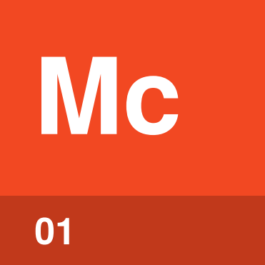 | MCP server  page 4
 | Client  page 4
Server entry  page 5 |  |  |  | 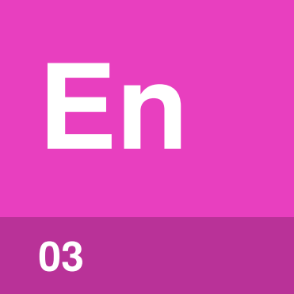
 |  |  | 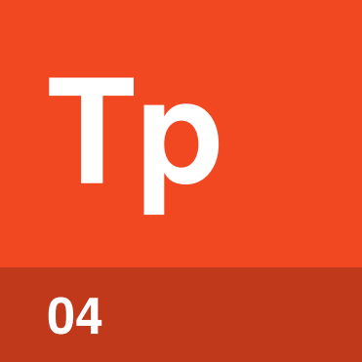 | Transport  page 5

What is MCP?
An agent can only act through tools, and the harness runs every tool call. MCP, the Model Context Protocol, is a standard way for a harness to offer the agent extra tools and data, such as your files, a database or a web service.
Someone writes a small program called an MCP server, and you add an entry for it to your harness’s settings. The harness starts the server or connects to it, asks what tools it has, and passes the agent’s calls to it. An Accidental Guide to: Agents, Harnesses, Skills, and Tools covers tools and tool calls.
“Server” can make you picture a service on another machine, but an MCP server is often a small program on your own machine. The harness does the asking, so in MCP the clients live in the harness.
Host | The specification’s word for the harness.
MCP server | A program that offers tools and data to a harness through MCP.
Client | The part of the harness that talks to one server.
Server entry | A setting that says how to start or reach a server.
Transport | How the client and server pass messages, through stdio or HTTP.

How do the parts fit together?
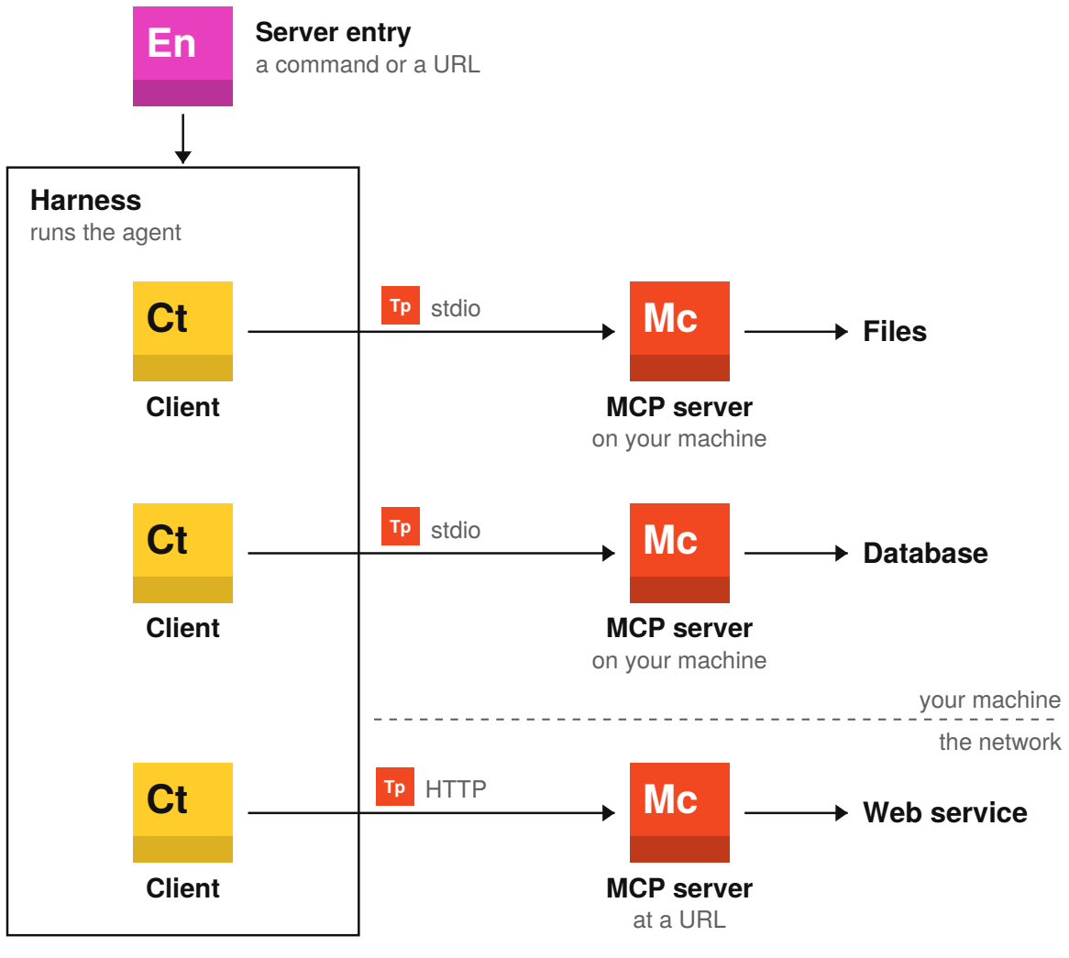
The server does the reaching, with its own code and credentials, and a local server can still call a web service. The GitHub MCP server, for example, can run on your machine and call GitHub’s web API, or run at GitHub’s own URL.

MCP server | 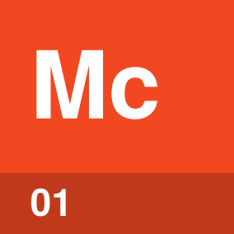

Identify by | A name in the harness’s MCP settings, such as github.
What | An MCP server is a program that offers tools to a harness over MCP. Some servers also offer resources and prompts.
So what | The same server works in every harness that supports MCP. The server holds the credentials for the system it reaches.

Field marks
Runs on  Your machine or a URL. | Cannot  See the conversation.

Confused with | Web service  A web service answers requests from any program. A local MCP server often calls one, and a remote MCP server is one.

Client | 

Identify by | Nothing you set up. The harness makes one for each server.
What | A client is the part of the harness that talks to one server. The client asks the server what it offers and passes the agent’s calls to it.
So what | One client per server keeps the servers apart. A server can’t see another server’s calls or results.

Field marks
Runs on  Inside the harness. | Cannot  Choose a tool.

Confused with | Harness  The harness is the whole program you start. A client is one part of it, so three servers mean three clients.

Server entry | 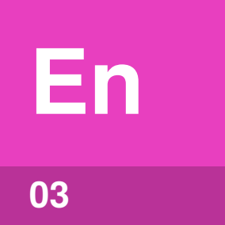

Identify by | An entry in .mcp.json for Claude Code, ~/.codex/config.toml for Codex or mcp.json for VS Code, as of October 2026.
What | A server entry is a name plus the command that starts a local server or the URL of a remote one. Commands such as claude mcp add write it for you.
So what | When a server’s tools don’t show up, check the entry first. A wrong command, URL or key blocks the connection.

Field marks
Kept in  A project or user file. | Cannot  Add tools by itself.

Confused with |  MCP server  The entry is a few lines of settings. The server is the program they start or point to.

Transport | 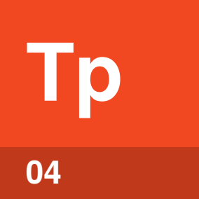

Identify by | A command or a URL in the server entry.
What | A transport is how the client and server pass messages. With stdio, the harness starts the server on your machine. With HTTP, the server runs at a URL.
So what | When a server won’t connect, check the command for stdio. For HTTP, check the URL and sign-in.

Field marks
Runs on  Local or remote. | Cannot  Change the tools.

Confused with | Remote server  HTTP usually means a remote server, but a server on your own machine can use HTTP too.

What can a server offer?
A server can offer three kinds of thing, and the difference is who picks each one.
Offer | Who picks it | Where you see it
Tools | The agent | Tool calls in the session, the same as built-in tools.
Resources | You or the harness | Data you attach, with an @ mention in Claude Code or Add Context in VS Code.
Prompts | You | Ready-made instructions you run as slash commands.

Agents mostly use tools, the only kind they pick for themselves, and as of October 2026 some harnesses support only tools.
Tip. Every tool definition takes room in the context window on every call, unless the harness loads definitions on demand, as Claude Code does by default. Add only the servers you use.

Common questions
Question | Answer
Is MCP a service? | No. MCP is a set of rules for the messages between a harness and a server.
Is MCP an AI model? | No. Your harness picks the model. MCP only carries calls, results and data.
Does an agent need MCP to use tools? | No. Built-in tools, scripts and CLIs work without it.

MCP is worth it when the same tools should work in several harnesses. Otherwise a script or CLI is often enough.

Sources
These public sources were checked in October 2026.
Model Context Protocol, Architecture overview
modelcontextprotocol.io/docs/learn/architecture
Model Context Protocol, Specification 2026-07-28
modelcontextprotocol.io/specification/2026-07-28
Anthropic, Claude Code: MCP
code.claude.com/docs/en/mcp
OpenAI, Codex: MCP
learn.chatgpt.com/docs/extend/mcp
Microsoft, VS Code: Use MCP servers
code.visualstudio.com/docs/copilot/chat/mcp-servers
GitHub Docs, Configure MCP servers for Copilot
docs.github.com/en/copilot/how-tos/copilot-on-github/customize-copilot/configure-mcp-servers


An Accidental Guide to…
Model Context Protocol
A pocket-sized guide to MCP servers and clients, as of October 2026.
Written and reviewed by a person. AI does the grunt work. Set in TeX Gyre Heros and Newsreader.
Leave a star: accidental.info/star

