An Accidental Guide to… | At the table 02 | 

Grilled
Cheese
A pocket-sized guide to crisp bread and melted cheese.
 Runs | Written | Checks |  Used |  Decided | Counted
 |  |  | 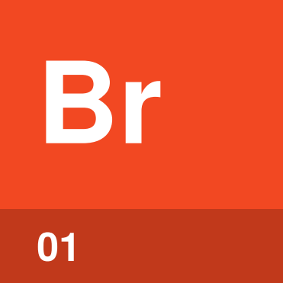 | Bread  page 4
 |  |  |  | Cheese  page 5
 |  |  |  | Butter  page 5
 |  |  |  |  | Heat  page 6

What makes a good
grilled cheese?
A good grilled cheese has crisp, golden bread around completely melted cheese. Keep the heat medium-low and give the cheese time to melt before the bread burns. Butter melted in the pan does the browning.
The job comes down to bread, cheese, butter and heat. Strong opinions about each are available, but lunch only needs all four working together.
Bread | The two slices that turn crisp and golden.
Cheese | The melting filling between the bread.
Butter | The fat that browns the outside.
Heat | The burner setting that controls the cooking speed.

How does it
come together?
Use about 1 tablespoon of butter for each sandwich. Cook until each side is golden and the cheese has melted.
Heat the pan | Set a skillet over medium-low heat.
Butter the pan | Melt about half a tablespoon of butter. Swirl it around the pan.
Add the sandwich | Put the cheese between two slices of bread, then lay the sandwich in the melted butter.
Cook the first side | Cook uncovered and without pressing until the bottom is golden, about 3 to 5 minutes.
Flip | Turn the sandwich over with a spatula, and add another half tablespoon of butter to the pan beside it.
Cook the second side | Cook for about 3 to 4 minutes, until golden and the cheese has melted.

Tip. Shredded cheese melts faster than sliced, so all of it melts before the bread finishes toasting.

Bread | 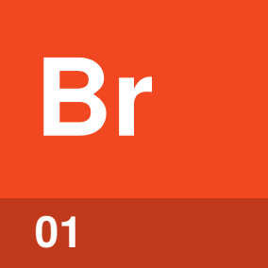

Identify by | Two slices cut from a loaf.
What | Bread is the outside of the sandwich, which turns crisp in the pan. Sliced white bread is the usual choice, and sourdough or potato bread work too.
So what | Sturdy bread holds the cheese in. Airy bread such as focaccia lets melted cheese seep through and burn.

Field marks
Rule of thumb  Use two sturdy slices. | Watch for  Large holes that leak cheese.

Confused with | Panini  A panini press closes on the sandwich and cooks both sides at once. A grilled cheese cooks one side at a time in an open pan.

Cheese | 

Identify by | Slices or a handful of shredded cheese.
What | Cheese is the filling that melts between the bread. American, sharp cheddar and Swiss all melt well.
So what | The cheese has to melt before the bread gets too dark. Shredded cheese melts faster than sliced.

Field marks
Rule of thumb  Choose a melting cheese. | Watch for  Sliced cheese melts slower.

Confused with | Hard cheese  Hard cheeses such as Parmesan and Manchego are better kept for a cheese board. A melting cheese such as American or cheddar goes in the sandwich.

Butter | 

Identify by | A pat melting and spreading across the pan.
What | Butter is the fat that browns the bread in the skillet. The bread soaks up melted butter from the pan as it cooks.
So what | Butter in the pan turns the bread crisp and golden. One tablespoon per sandwich gives each side half a tablespoon.

Field marks
Rule of thumb  Half a tablespoon per side. | Watch for  Butter smoking or browning fast.

Confused with | Mayonnaise  Mayonnaise is spread on the outside of the bread. Mayonnaise has a higher smoke point than butter, so it browns without burning.

Heat | 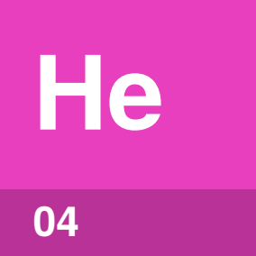

Identify by | The burner knob set slightly lower than the middle.
What | Heat is how hot the skillet gets while the sandwich cooks. Medium-low gives each side 3 to 5 minutes to turn golden.
So what | Medium-low heat gives the cheese time to melt. High heat can brown the bread before the cheese melts.

Field marks
Rule of thumb  Keep the heat medium-low. | Watch for  Dark bread and cold cheese.

Confused with | Lid  A lid traps heat to melt the cheese faster. A lid can also steam the bread soft.

What’s worth arguing about?
Every camp makes a good sandwich, as long as the bread browns and the cheese melts.
Butter the bread or the pan? | Spreading about a tablespoon of butter on the outside of the bread works. Melting the same amount in the pan works too, and the bread soaks it up.
Butter or mayonnaise? | Butter soaks into the bread and tastes of butter. Mayonnaise has a higher smoke point, so it can brown the bread without burning.
Lid or no lid? | A lid traps heat and melts the cheese faster. The trapped steam can also make the bread soggy.
Press it flat? | Don’t press the sandwich. Let each side cook undisturbed until it is golden.

Sources
These public sources were checked in October 2026.
Food Network Kitchen, A Precise Guide to Making Perfect Grilled Cheese Sandwiches
April 2026 · foodnetwork.com/how-to/packages/food-network-essentials/how-to-make-grilled-cheese
Food Network Kitchen, Grilled Cheese Sandwiches
October 2026 · foodnetwork.com/recipes/food-network-kitchen/grilled-cheese-sandwiches-recipe2-1944002
Epicurious, How to Make Crispy, Butter-Basted Grilled Cheese
January 2016 · epicurious.com/expert-advice/extra-crispy-grilled-cheese-tip-article
King Arthur Baking, 5 Tips for the Best Grilled Cheese Ever
March 2015 · kingarthurbaking.com/blog/2015/03/19/grilled-cheese


An Accidental Guide to…
Grilled Cheese
A pocket-sized guide to crisp bread and melted cheese.
Written and reviewed by a person. AI does the grunt work. Set in TeX Gyre Heros and Newsreader.
Leave a star: accidental.info/star

