An Accidental Guide to… | At the table 04 | 

Giving a
Toast
A pocket-sized guide to giving a short, warm toast.
 Runs |  Written | Checks | Used | Decided |  Counted
 | 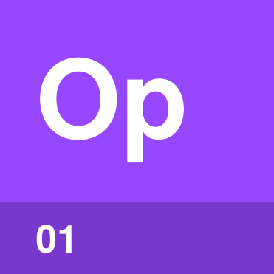 | Opening  page 4
 | 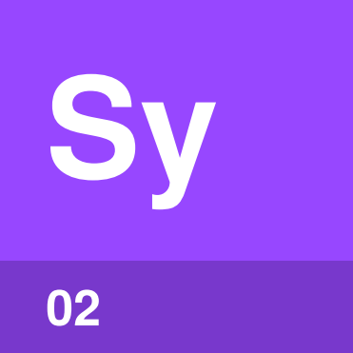 | Story  page 4
 | 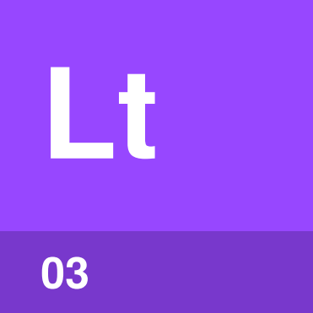 | Last line  page 5
Length  page 5 |  |  |  |  | 

What goes in a toast?
A toast needs three things: a quick introduction, one short story or quality and a last line that asks everyone to raise a glass. Keep the whole thing positive and aim for two to three minutes.
Tie what you say to the occasion. Lean toward sentiment at a wedding and toward nostalgia when someone retires.
Opening | Your name and how you know the person you’re toasting.
Story | One kind story or quality that everyone can follow.
Last line | An invitation to raise a glass and drink.
Length | Two to three minutes from start to finish.

How does a toast go?
Toasts usually come once drinks are poured, at the start of the meal or just before dessert. A toast then follows six small steps.
Get attention | Stand, lift your glass or wait quietly until people notice. Don’t bang on a glass.
Stand and lift your glass | Stand to signal the start. At a small, informal meal, you can stay seated.
Opening | Say your name and how you know the person you’re toasting.
Story | Tell one short, kind story or describe one positive quality.
Last line | Raise your glass and invite everyone to join you: “To Sam.”
Everyone drinks | Everyone except the person being toasted takes a sip.

Tip. Write a few points on a notecard, then practise the toast out loud. You’ll hear where a sentence is too long before the room does.

Opening | 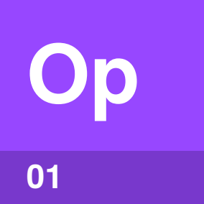

Identify by | The first sentence after the room goes quiet.
What | The opening is the first thing you say. Give your name and explain how you know the person you’re toasting.
So what | Guests who don’t know you can place you straight away. That makes the story easier to follow.

Field marks
Rule of thumb  Name and connection. | Watch for  Starting the story too soon.

Confused with | Getting attention  Getting attention comes first and needs no words. The opening begins when you start speaking.

Story | 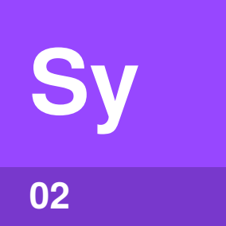

Identify by | The one memory or quality you share.
What | The story is one short memory or one positive quality. Pick something the whole room can follow.
So what | One main idea keeps the toast easy to follow. A kind story keeps the attention on the person you’re toasting.

Field marks
Rule of thumb  One short, positive idea. | Watch for  Inside jokes and private details.

Confused with | Roast  A roast teases someone for a laugh. A toast celebrates them, so a touch of clean humour is fine, but leave out anything embarrassing or too personal.

Last line | 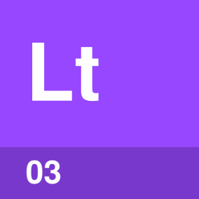

Identify by | Your final words with your glass raised.
What | The last line invites everyone to join the toast. Raise your glass and say something short, such as “To Sam.”
So what | A clear last line tells the room when to drink. Everyone else raises a glass together.

Field marks
Rule of thumb  End with the invitation. | Watch for  Forgetting to raise your glass.

Confused with | Reply  Your last line invites everyone to drink. The reply belongs to the person being toasted, who smiles, nods or says thank you without drinking to themselves.

Length | 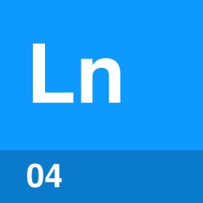

Identify by | The time from your first word to the raised glass.
What | Length is how long you speak. Two to three minutes is the aim for a toast you prepare.
So what | A short toast keeps the attention on the person you’re toasting. Practise out loud to check the time.

Field marks
Rule of thumb  Two to three minutes. | Watch for  More than one main idea.

Confused with | Casual toast  At a casual dinner, a few heartfelt sentences are enough, ending with something like “To our hosts.” Two to three minutes suits a toast you prepare.

What do I leave out?
Inside jokes | Most of the room won’t understand them.
Embarrassing stories | Off-limits. The spotlight belongs on the person you’re toasting.
Overly personal details | A toast isn’t the time to overshare.
Rambling | More than one main idea makes the toast hard to follow.

Common questions
Who goes first? | The host may give the first toast, at a dinner party or a wedding. If the host doesn’t, a guest may toast the hosts.
Do I stand? | Stand when you give a toast. You can stay seated at a small, informal meal.
Do I need a drink? | You don’t need alcohol. Raise whatever you’re drinking. A sip is enough.
What does the person being toasted do? | The person being toasted stays seated and doesn’t drink. A smile, nod or thank you is enough.

Sources
These public sources were checked in October 2026.
Toastmasters International, How to Give a Toast
October 2026 · toastmasters.org/Resources/Public%20Speaking%20Tips/How%20to%20Give%20a%20Toast
Emily Post Institute, All About Toasting
October 2026 · emilypost.com/advice/all-about-toasting
Emily Post Institute, Toasts and Toasting: Tips You Can Use Today
October 2026 · emilypost.com/advice/toasts-and-toasting-tips-you-can-use-today
Emily Post Institute, The Groom’s Toast
October 2026 · emilypost.com/advice/the-grooms-toast


An Accidental Guide to…
Giving a Toast
A pocket-sized guide to giving a short, warm toast.
Written and reviewed by a person. AI does the grunt work. Set in TeX Gyre Heros and Newsreader.
Leave a star: accidental.info/star

