An Accidental Guide to… | Accidental Intelligence 05 | 

OpenAI
Codex
A pocket-sized guide to where Codex keeps its setup, and which copy wins, as of October 2026.
 Runs |  Written | Checks |  Used |  Decided | Counted
 |  | Instructions file  page 3
 | 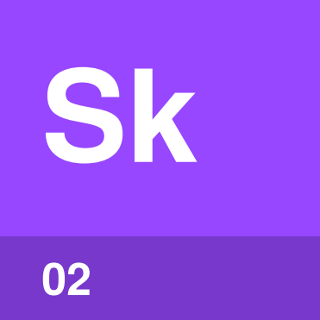 | Skill  page 3
 |  |  | 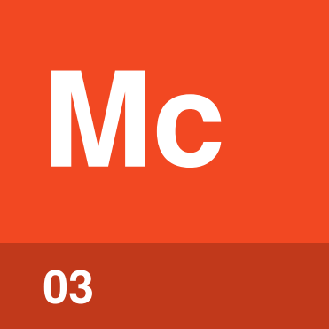 | MCP server  page 4
 |  |  |  |  | Config file  page 4
Permissions  page 5 |  |  |  | 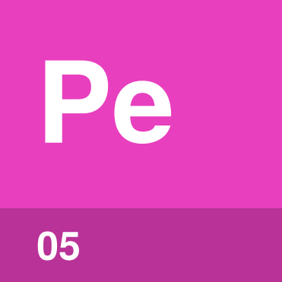

What can you set up
in Codex?
You can give Codex standing instructions, skills, MCP servers, settings and permissions. Each one is a plain file, and the Codex CLI, the IDE extension and the ChatGPT desktop app all read the same files.
Most of these files live in your Codex home folder, ~/.codex unless CODEX_HOME says otherwise, or in your project. An Accidental Guide to: Agents, Harnesses, Skills, and Tools explains the basics.
Instructions file | Guidance Codex reads at the start of every session.
Skill | Steps for one kind of task, read when the task comes up.
MCP server | A program that gives Codex tools for another system.
Config file | The file that holds settings such as the model and MCP servers.
Permissions | What commands may change, and when Codex stops to ask you.

Instructions file | 

Identify by | AGENTS.md, in ~/.codex/ or anywhere in a project.
What | Codex reads your AGENTS.md, then each one from the project’s root down to where you work. An Accidental Guide to: Agents, Harnesses, Skills, and Tools explains them.
So what | Put guidance in the folder it’s about. The file closest to your work has the last word.

Field marks
Loads  At the start of a session. | Add with  /init.

Confused with |  Skill  Codex reads an instructions file every session. A skill’s steps are read only when the skill is used.

Skill | 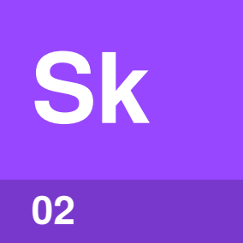

Identify by | A folder with a SKILL.md file.
What | Codex reads the rest of a skill when your task matches its description, or when you type $ and its name. An Accidental Guide to: Agent Skills explains skills.
So what | A project’s skills in .agents/skills/ reach everyone who works on it.

Field marks
Loads  Description first. | Check with  /skills.

Confused with | Plugin  A plugin packages skills, MCP servers and hooks to install together, using /plugins in the CLI.

MCP server | 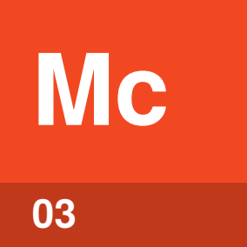

Identify by | A [mcp_servers.docs] table in config.toml.
What | Each server’s entry gives a command that starts it on your computer, or the url of a remote one. An Accidental Guide to: Model Context Protocol explains MCP servers.
So what | Set a server up once and it works in the CLI, the IDE extension and the desktop app.

Field marks
Add with  codex mcp add. | Check with  /mcp.

Confused with | Tool  The MCP server is the program. The tools it offers are what Codex calls.

Config file | 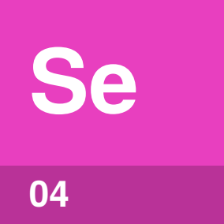

Identify by | config.toml, in ~/.codex/ or in a project’s .codex/ folder.
What | Settings are the choices that control how Codex runs, such as the model. Codex keeps them in config.toml, along with MCP servers and permissions.
So what | Your own config.toml applies everywhere, and a project’s .codex/config.toml changes settings for that project.

Field marks
Loads  When Codex starts. | Override with  -c for one run.

Confused with | Requirements file  Your config.toml sets defaults you can change. An administrator’s requirements.toml sets limits you can’t.

Permissions | 

Identify by | sandbox_mode and approval_policy in config.toml.
What | Codex has two permission settings. The sandbox decides what commands can touch: read-only, workspace-write or danger-full-access. The approval policy, on-request or never, decides when Codex stops to ask. An Accidental Guide to: Agents, Harnesses, Skills, and Tools explains permissions.
So what | The sandbox keeps a wrong command away from everything outside your work. In a Git folder Codex starts with workspace-write and on-request, and elsewhere read-only.

Field marks
Network  Off by default. | Change with  /permissions.

Confused with | Rules  Rules files in ~/.codex/rules/ say whether a command may run outside the sandbox: allow, prompt or forbidden.

Where things live
Your own files apply in every project. A project’s files are kept in its repository.
Your home folder
 Instructions | ~/.codex/AGENTS.md, or AGENTS.override.md beside it
Skills | ~/.agents/skills/
 Config file | ~/.codex/config.toml, which also holds MCP servers and permissions, with profiles beside it
Hooks, rules, agents | ~/.codex/hooks.json, ~/.codex/rules/, ~/.codex/agents/

This project
Instructions | AGENTS.md in any folder
Skills | .agents/skills/ in any folder
Config file | .codex/config.toml
Hooks, rules, agents | .codex/hooks.json, .codex/rules/, .codex/agents/

Your organization
Config file | /etc/codex/config.toml, or defaults from the admin console
Skills | /etc/codex/skills/
Requirements | /etc/codex/requirements.toml, or the admin console

Codex Cloud
Skills | Only the repository’s skills. Personal skills aren’t synced.

Note. Codex reads a project’s .codex folder only after you trust the project, so a repository you haven’t trusted can’t change your settings, hooks or rules.

How do the places combine?
Config file | Where the value comes from, strongest first
1 | A flag or -c on the command line
2 | The project’s .codex/config.toml closest to where you work
3 | A profile picked with --profile
4 | Your ~/.codex/config.toml
5 | Your organization’s defaults
6 | Codex’s built-in defaults

Other setup | When two places set it
Instructions | Codex joins them, yours first, then the project’s from the root down, so the closest file has the last word.
Skills | Codex offers all of them. Two with the same name both appear.
 MCP servers | Servers can be in your config.toml or a project’s, and a setting for the same server follows the numbered list.
Hooks | Codex keeps all of them.
Rules | The strictest match wins: forbidden, then prompt, then allow.

Same thing elsewhere
Codex | Claude Code | Claude Desktop | Copilot CLI | VS Code and Visual Studio
Instructions file | CLAUDE.md | Instructions | AGENTS.md | AGENTS.md
Skill | Skills | Skills | Skills | Skills
MCP server | .mcp.json | Connectors | .mcp.json | .mcp.json
Config file | settings.json | Settings | settings.json | Settings
 Permissions | settings.json | Settings | Settings | Settings

Each of these tools has its own guide: An Accidental Guide to: Claude Code, An Accidental Guide to: Claude Desktop, An Accidental Guide to: GitHub Copilot CLI, and An Accidental Guide to: VS Code and Visual Studio.

Sources
These public sources were checked on 22 October 2026.
Config basics
OpenAI · learn.chatgpt.com/docs/config-file/config-basic
Advanced Configuration
OpenAI · learn.chatgpt.com/docs/config-file/config-advanced
Custom instructions with AGENTS.md
OpenAI · learn.chatgpt.com/docs/agent-configuration/agents-md
Build skills
OpenAI · learn.chatgpt.com/docs/build-skills
Model Context Protocol
OpenAI · learn.chatgpt.com/docs/extend/mcp
Agent approvals and security
OpenAI · learn.chatgpt.com/docs/agent-approvals-security
Package your plugin
OpenAI · developers.openai.com/plugins/build/plugins
Hooks
OpenAI · learn.chatgpt.com/docs/hooks
Rules
OpenAI · learn.chatgpt.com/docs/agent-configuration/rules
Cloud environments
OpenAI · learn.chatgpt.com/docs/environments/cloud-environments
Managed configuration
OpenAI · learn.chatgpt.com/docs/enterprise/managed-configuration


An Accidental Guide to…
OpenAI Codex
A pocket-sized guide to where Codex keeps its setup, and which copy wins, as of October 2026.
Written and reviewed by a person. AI does the grunt work. Set in TeX Gyre Heros and Newsreader.
Leave a star: accidental.info/star

