An Accidental Guide to… | Accidental Intelligence 03 | 

Claude
Desktop
A pocket-sized guide to where Claude Desktop keeps its settings, as of October 2026.
 Runs |  Written | Checks |  Used |  Decided | Counted
 |  | Instructions  page 3
 | 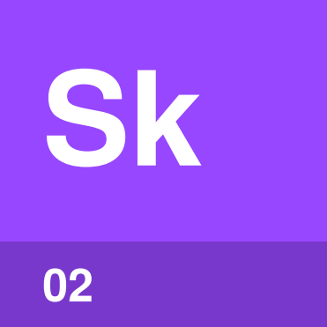 | Skills  page 3
 |  |  | 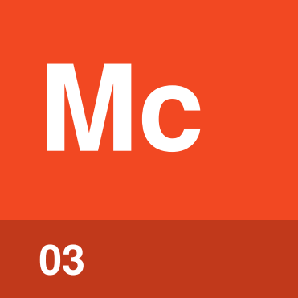 | Connectors  page 4
 |  |  | 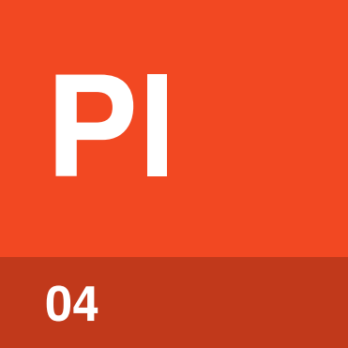 | Plugins  page 4
Settings and permissions  page 5 |  |  |  | 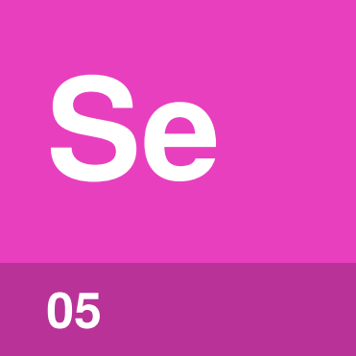

What can you set up
in Claude Desktop?
In Claude Desktop you can tell Claude how to answer you, save the steps for tasks you repeat, connect Claude to the apps you use, and choose what Claude may do without asking. Most of these settings belong to your Claude account and also apply on claude.ai.
You’ll find them in Settings and in Customize, in the left sidebar. An Accidental Guide to: Agents, Harnesses, Skills, and Tools explains the basics.
Instructions | What you want Claude to know in every chat, or in one project.
Skills | Saved steps Claude follows for one kind of task.
Connectors | An MCP server you add so Claude can reach another app or service.
Plugins | A package of skills, connectors and sub-agents.
Settings and permissions | Your preferences, and how much Claude may do before it asks.

Instructions | 

Identify by | Settings > General, or a project’s page.
What | Instructions are text you write for Claude to follow, in all your chats or in one project. An Accidental Guide to: Agents, Harnesses, Skills, and Tools explains instructions.
So what | Put a preference you always want in Settings, and one for a single piece of work in that project.

Field marks
Works in
Web, desktop, mobile.

Confused with | Memory  Memory is what Claude picks up from your chats, in Settings > Memory. Instructions are what you write yourself.

Skills | 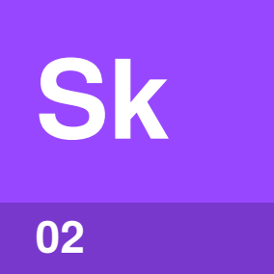

Identify by | Customize > Skills.
What | A skill is a saved set of steps for one kind of task, which Claude follows when that task comes up. An Accidental Guide to: Agent Skills explains skills.
So what | You explain a task once instead of in every chat. Skills need Code execution, in Settings > Capabilities.

Field marks
Works in
Web, desktop and Claude Code.

Confused with |  Instructions  Instructions apply to every chat. A skill’s steps apply only to its kind of task.

Connectors | 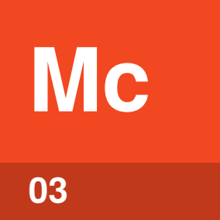

Identify by | Customize > Connectors, or the + button in the message box.
What | A connector is an MCP server on the internet, usually for a service you sign in to. An Accidental Guide to: Model Context Protocol explains MCP servers.
So what | For each of a connector’s tools you choose Always allow, Needs approval or Blocked.

Field marks
Works in
Web, desktop, mobile.

Confused with | Desktop extension  A desktop extension is a local MCP server in a .mcpb file, installed in Settings > Extensions. Extensions work only on this computer.

Plugins | 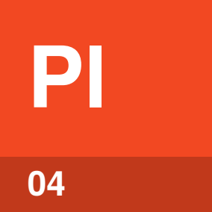

Identify by | Customize > Plugins, on the Discover tab.
What | A plugin is a package of skills, connectors and sub-agents, saved to your account. An Accidental Guide to: Plugins, Connectors, and Marketplaces explains plugins.
So what | One install sets up what you need for a role. Plugins need a paid plan, and your organization may install some for you.

Field marks
Works in
Chat, Cowork and Claude Code.

Confused with |  Skills  A skill is one set of steps. A plugin can hold several skills, plus connectors and sub-agents.

Settings and permissions | 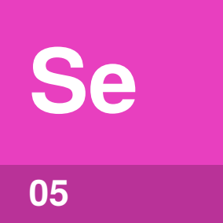

Identify by | Settings, under your initials, and the permission setting in the message box.
What | Settings holds your account’s preferences, such as General, Capabilities and Memory. Extensions and Developer apply to this computer only.
So what | The permission setting decides how much Claude does without asking. The default is Manual.

Field marks
Works in
Account and computer.

Confused with | Customize  Customize is where you add skills, connectors and plugins. Settings is where you set preferences and permissions.

Where things live
Most things live in your Claude account and show up wherever you sign in. A few live on this computer only.
What | Lives in | Where to find it
Instructions | Account | Settings > General, and each project’s page
Memory | Account | Settings > Memory
Skills | Account | Customize > Skills
 Connectors | Account | Customize > Connectors, then a connector for its tool permissions
 Plugins | Account | Customize > Plugins
Code execution | Account | Settings > Capabilities
Folder access | Computer | Settings, under Trusted folders
Desktop extensions | Computer | Settings > Extensions
Local MCP servers | Computer | Settings > Developer > Edit Config  macOS: ~/Library/Application Support/Claude/claude_desktop_config.json  Windows: %APPDATA%\Claude\claude_desktop_config.json
Code tab | Computer | ~/.claude/settings.json and ~/.claude/skills, the same files Claude Code uses

Chats and Cowork use what’s in Customize. The Code tab reads ~/.claude, as Claude Code does. See An Accidental Guide to: Claude Code.
Tip. After you edit claude_desktop_config.json, quit Claude Desktop completely and open it again.

Your account or
your organization?
On Free, Pro and Max plans you set everything yourself. On Team and Enterprise plans, an owner sets limits in Organization settings.
Setting | You | An owner, in Organization settings
Skills | Turn on or upload | Plugins & skills: turn skills on, add skills for everyone, stop people creating skills
Connectors | Add and sign in | Connectors: add for the team, set limits nobody can override
Plugins | Add from Discover | Add marketplaces, require plugins
Desktop extensions | Install allowed ones | Connectors, Desktop tab: the allowlist
Memory | Turn on or off | Capabilities: allow memory

On computers your company manages, IT can set the desktop app’s options in com.anthropic.claudefordesktop on macOS or HKLM\SOFTWARE\Policies\Claude on Windows.

Same thing elsewhere
Coding tools keep the same kinds of things in their own files.
In Claude Desktop | Elsewhere
Instructions | CLAUDE.md in Claude Code. AGENTS.md in Codex, Copilot CLI and VS Code.
Skills | A folder with a SKILL.md file, under ~/.claude/skills in Claude Code. Codex, Copilot CLI and VS Code have skills too.
Connectors | MCP servers: .mcp.json in Claude Code, ~/.codex/config.toml in Codex, the User or Workspace group in VS Code
Plugins | Plugins in all four
 Settings and permissions | ~/.claude/settings.json in Claude Code, approval_policy and sandbox_mode in ~/.codex/config.toml

See An Accidental Guide to: Claude Code, An Accidental Guide to: GitHub Copilot CLI, An Accidental Guide to: OpenAI Codex and An Accidental Guide to: VS Code and Visual Studio.

Sources
These public sources were checked on 22 October 2026. The Anthropic Help Center articles, listed first, are at support.claude.com/en/articles/ and their number.
Use connectors · 11176164
Desktop and web connectors · 11725091
Local MCP servers on Claude Desktop · 10949351
Desktop extension allowlist · 12592343
Enterprise configuration for Claude Desktop · 12622667
Use skills in Claude · 12512180
Use plugins in Claude · 13837440
Personalization features · 10185728
Cowork and chat are one Claude · 16761823
Create and manage projects · 9519177
Chat search and memory · 11817273
Anthropic, Claude Code on desktop
code.claude.com/docs/en/desktop
Model Context Protocol, Connect to local MCP servers
modelcontextprotocol.io/docs/develop/connect-local-servers
OpenAI, Codex config basics
learn.chatgpt.com/docs/config-file/config-basic
OpenAI, Codex AGENTS.md
learn.chatgpt.com/docs/agent-configuration/agents-md
GitHub, Copilot customization cheat sheet
docs.github.com/en/copilot/reference/customization-cheat-sheet
Visual Studio Code, Agent customization overview
code.visualstudio.com/docs/agent-customization/overview


An Accidental Guide to…
Claude Desktop
A pocket-sized guide to where Claude Desktop keeps its settings, as of October 2026.
Written and reviewed by a person. AI does the grunt work. Set in TeX Gyre Heros and Newsreader.
Leave a star: accidental.info/star

