An Accidental Guide to… | Accidental Intelligence 02 | 

Claude Code
A pocket-sized guide to where Claude Code keeps its setup, as of October 2026.
 Runs |  Written | Checks |  Used |  Decided | Counted
 |  | Instructions file  page 3
 | 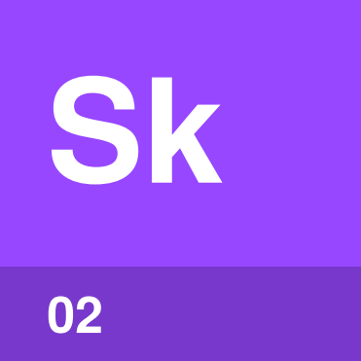 | Skill  page 3
 |  |  | 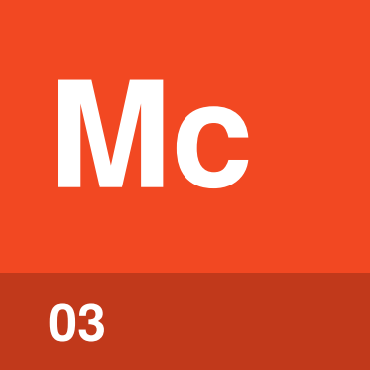 | MCP server  page 4
 |  |  | 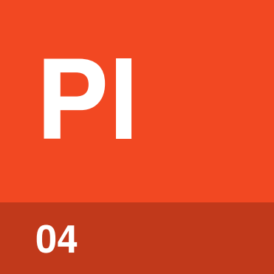 | Plugin  page 4
 |  |  |  | 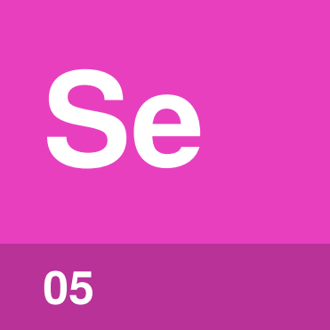 | Settings  page 5

What can you set up
in Claude Code?
Claude Code reads its setup from plain files, some in your home folder and some in the project. There are five kinds: instructions files, skills, MCP servers, plugins and settings.
Each kind can be yours alone, shared with the project, or set by your organization. An Accidental Guide to: Agents, Harnesses, Skills, and Tools explains the basics.
Instructions file | Text added to every session, such as build commands.
Skill | A written procedure, loaded when a task needs it.
MCP server | A program that gives Claude Code tools for another system.
Plugin | A package of skills, MCP servers and hooks, installed together.
Settings | JSON files for permissions, hooks and other behavior.

Instructions file | 

Identify by | CLAUDE.md, or AGENTS.md.
What | An instructions file holds what Claude Code should know in every session. Claude Code reads AGENTS.md only when there’s no CLAUDE.md. An Accidental Guide to: Agents, Harnesses, Skills, and Tools explains instructions files.
So what | Write down what you’d otherwise explain again each session. Run /init to start a CLAUDE.md.

Field marks
Loads  At every session start. | Cannot  Enforce a rule.

Confused with |  Settings  Instructions are guidance the model reads. Settings are rules Claude Code enforces.

Skill | 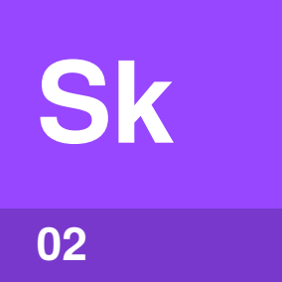

Identify by | A folder with a SKILL.md file.
What | A skill is a written procedure that Claude Code loads when a task needs it, or when you type its name, such as /deploy. An Accidental Guide to: Agent Skills explains skills.
So what | Steps needed only for some tasks belong in a skill, so they don’t fill every session.

Field marks
Loads  Description at startup. | Cannot  Add a tool.

Confused with |  Instructions file  An instructions file loads in full every session. A skill loads in full only when it’s used.

MCP server | 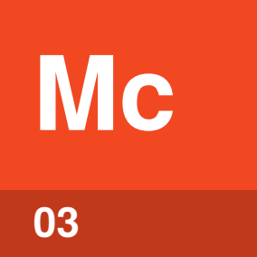

Identify by | An entry under mcpServers, with a start command or a URL.
What | An MCP server is a separate program that gives Claude Code tools for another system. Add one with claude mcp add. An Accidental Guide to: Model Context Protocol explains MCP servers.
So what | Servers in a project’s .mcp.json wait for your approval, so a cloned repository can’t connect them without you.

Field marks
Loads  When the session starts. | Cannot  Act on its own.

Confused with |  Plugin  A plugin can bring its own MCP server. You add or remove that server along with the plugin.

Plugin | 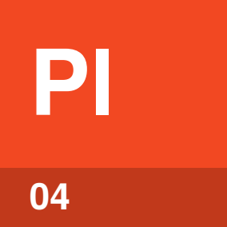

Identify by | A folder with .claude-plugin/plugin.json.
What | A plugin bundles skills, hooks and MCP servers. Most come from a marketplace. An Accidental Guide to: Plugins, Connectors, and Marketplaces explains plugins.
So what | An enabled plugin is part of every session and runs as you. Check what a plugin adds before you install it.

Field marks
Loads  At startup, if turned on. | Cannot  Install for teammates.

Confused with |  Skill  A skill is one folder you can copy in yourself. A plugin is a package that can carry many skills and other parts.

Settings | 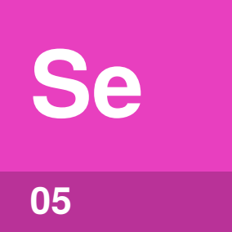

Identify by | settings.json, settings.local.json or managed-settings.json.
What | Settings are JSON files that decide which commands run without asking, which hooks run and which plugins are on.
So what | Permission rules allow, ask about or deny tool calls. Hooks run commands at set points, such as before a tool call.

Field marks
Loads  At startup and on save. | Cannot  Override your organization.

Confused with | Instructions file  Claude Code enforces settings. The model reads an instructions file as guidance.

Where do the
files live?
Most setup sits in two .claude/ folders, one in your home folder and one in the project.
User: you, in every project
Instructions | ~/.claude/CLAUDE.md
Skills | ~/.claude/skills/
 MCP servers | ~/.claude.json
Plugins | ~/.claude/plugins/, turned on in ~/.claude/settings.json
Settings | ~/.claude/settings.json

Project: shared with the team, and local: only you
Instructions | CLAUDE.md or .claude/CLAUDE.md, and CLAUDE.local.md for local
Skills | .claude/skills/
MCP servers | .mcp.json, and ~/.claude.json for local
Plugins | turned on in the project’s settings files
Settings | .claude/settings.json, and .claude/settings.local.json for local

Managed: set by your organization
Folder | /Library/Application Support/ClaudeCode/ on macOS, /etc/claude-code/ on Linux, C:\Program Files\ClaudeCode\ on Windows
Instructions | CLAUDE.md in that folder
Skills | .claude/skills/ in that folder
MCP servers | managed-mcp.json in that folder
Settings | managed-settings.json in that folder, or a policy from MDM or the admin console

Tip. /status shows which settings files loaded, /context the instructions files, /mcp the servers and /plugin the plugins.

Which one wins?
Some kinds add up across places. For others, one place wins.
Thing | When it’s set in more than one place
Settings | Highest first: managed, the --settings flag, local, project, user. Lists such as permission rules combine.
Permission rules | Deny is checked first, then ask, then allow, so a deny anywhere blocks the call.
Hooks | All of them run.
Instructions | All of them load. The file closest to where you started is read last.
Skills | Same name: managed, then user, then project. Plugin skills carry the plugin’s name, so they don’t clash.
MCP servers | Same name: local, then project, then user, then plugins.
Plugins | Local, then project, then user.

Run /status to see which managed settings apply.

The same things
in other tools
Each of these tools has its own guide.
Guide | What to look for there
An Accidental Guide to: Claude Desktop | Most setup is in the app. Local MCP servers go in claude_desktop_config.json.
An Accidental Guide to: GitHub Copilot CLI | AGENTS.md or .github/copilot-instructions.md, .github/skills/, and ~/.copilot/ for settings and MCP servers.
An Accidental Guide to: OpenAI Codex | AGENTS.md, .agents/skills/, and ~/.codex/config.toml for settings and MCP servers.
An Accidental Guide to: VS Code and Visual Studio | .github/copilot-instructions.md, .github/skills/ in VS Code, and a .mcp.json file for MCP servers.

Codex, GitHub Copilot CLI and VS Code read AGENTS.md, and Claude Code reads it when there’s no CLAUDE.md. GitHub Copilot CLI and VS Code also read .claude/skills/.

Sources
Checked in October 2026. Claude Code changes often, so check the current docs before you rely on a path.
Claude Code: Settings
code.claude.com/docs/en/settings
Claude Code: Managed settings
code.claude.com/docs/en/managed-settings
Claude Code: Memory
code.claude.com/docs/en/memory
Claude Code: The .claude directory
code.claude.com/docs/en/claude-directory
Claude Code: Skills
code.claude.com/docs/en/skills
Claude Code: MCP
code.claude.com/docs/en/mcp
Claude Code: Install plugins
code.claude.com/docs/en/plugins/install
Claude Code: Permissions
code.claude.com/docs/en/permissions
Claude Code: Hooks
code.claude.com/docs/en/hooks
MCP: Connect to local servers
modelcontextprotocol.io/docs/develop/connect-local-servers
GitHub: Copilot CLI configuration
docs.github.com/en/copilot/reference/copilot-cli-reference/cli-config-dir-reference
OpenAI: Codex configuration
learn.chatgpt.com/docs/config-file/config-basic
VS Code: Agent skills
code.visualstudio.com/docs/copilot/customization/agent-skills


An Accidental Guide to…
Claude Code
A pocket-sized guide to where Claude Code keeps its setup, as of October 2026.
Written and reviewed by a person. AI does the grunt work. Set in TeX Gyre Heros and Newsreader.
Leave a star: accidental.info/star

