An Accidental Guide to… | Around the house 01 | 

Smoke
Detectors
That Chirp
A pocket-sized guide to finding the smoke alarm that’s chirping, and making it stop.
 Runs | Written |  Checks |  Used |  Decided |  Counted
 |  |  | Chirp  page 4
 |  | 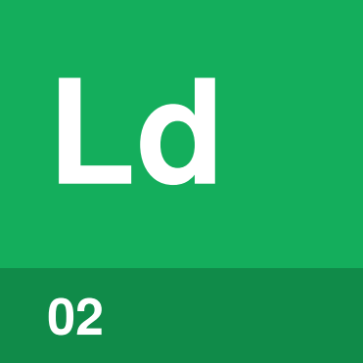 | Indicator light  page 4
 |  |  | 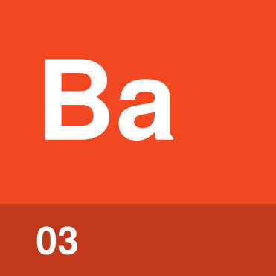 | Battery  page 5
Hush button  page 5 |  |  |  | 
Manufacture date  page 6 |  |  |  |  | 

Why is my smoke
alarm chirping?
One short chirp every 30 to 60 seconds or so means a smoke alarm wants attention, not that there’s a fire. The usual cause is a low battery.
A weak battery struggles as the house cools, and most homes are coolest between 2 a.m. and 6 a.m. That’s why the chirp so often starts in the middle of the night.
Chirp | A single short beep that asks for attention.
Indicator light | The small light, or LED, whose blinking shows the smoke alarm’s condition.
Battery | Main power, or backup power in a hardwired smoke alarm.
Hush button | Quiets the smoke alarm for a while without fixing anything.
Manufacture date | When the smoke alarm was made. Replace it 10 years later.

Which one is it?
A chirp is hard to place by ear. The smoke alarm with the problem may blink differently, so use your eyes as well.
Wait | Stand still until the next chirp. A minute can feel long at night.
Look | Check each indicator light. The one that needs attention may blink differently from the rest.
Narrow it down | Move room by room between chirps until the sound is loudest, then look at that smoke alarm’s light.
Check the date | If it’s hardwired, turn off its breaker. Then take that smoke alarm down and read the date on the back.

Watch out. Never take out the battery or disconnect a smoke alarm to stop a chirp. A smoke alarm with a dead or missing battery is the same as none at all.

Chirp | 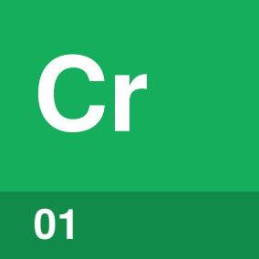

Identify by | A short, high beep with a long pause.
What | A chirp is the smoke alarm asking for attention. A low battery is the usual cause, and other patterns vary by model.
So what | A chirp that stops by morning can return the next night. Change the battery anyway.

Field marks
Found on  One smoke alarm, usually. | Fixed by  Battery or smoke alarm. | Cannot  Warn you of smoke.

Confused with | Alarm sound  A chirp is one short beep with a long pause. The alarm sound is loud and repeating, and means get out.

Indicator light | 

Identify by | A small light on the cover, often red or green.
What | An indicator light shows the smoke alarm’s condition. Some models blink a special pattern when the battery is low.
So what | When you can’t place the chirp, compare the lights. The odd one out may be the one to fix.

Field marks
Found on  The front cover. | Fixed by  Fixing what it shows. | Cannot  Mean the same on every model.

Confused with | Standby blink  A standby blink is a regular flash, on some models every 40 seconds, that means all is well. Compare the lights side by side.

Battery | 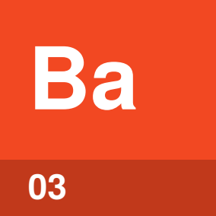

Identify by | A battery under a door or the cover, of the type on the label.
What | A battery powers the smoke alarm, or backs up a hardwired one. Change it at least once a year.
So what | A new battery usually stops the chirp. Some smoke alarms keep chirping until they’re reset.

Field marks
Found on  Under the cover. | Fixed by  A new battery. | Cannot  Fix an old smoke alarm.

Confused with | Sealed battery  A replaceable battery comes out. A sealed battery lasts the smoke alarm’s whole life, so when one chirps, replace the smoke alarm.

Hush button | 

Identify by | A button marked Hush or Silence, often the test button too.
What | A hush button quiets a nuisance alarm, such as cooking smoke, for a few minutes. On some models it also quiets a low-battery chirp for some hours.
So what | A hush may buy a night’s sleep but fixes nothing. The chirp comes back.

Field marks
Found on  The cover. | Fixed by  Battery or smoke alarm. | Cannot  Remove the cause.

Confused with | Test button  Many smoke alarms use one button for both. Press it during a chirp to hush, and at other times to test, at least once a month.

Manufacture date | 

Identify by | A date printed on the back or outside.
What | The manufacture date is when the smoke alarm was made. Sensors wear out, so replace it 10 years after that date.
So what | An old smoke alarm can be slow to sense a fire. If there’s no date, replace it now.

Field marks
Found on  The back or outside. | Fixed by  A new smoke alarm. | Cannot  Be reset.

Confused with |  Battery  The manufacture date never changes. A replaceable battery wears out much sooner.

What does the sound mean?
Sound | Means | Do this
One chirp about every 30 to 60 seconds | Usually a low battery | Replace the battery, then press test.
Chirping after a new battery | End of life, or a stored fault | Reset it: breaker off if hardwired, battery out, hold test 15 seconds, then put it back. Still chirping means replace it.
Three long beeps repeating | Smoke or fire | Get out, call 9-1-1 and stay out.
Four beeps repeating on a combination alarm | Carbon monoxide | Go outside, call 9-1-1 and stay out.

Other patterns vary by model, so check the label or manual.

Sources
These public sources were checked in October 2026.
NFPA, Educational Messages Desk Reference, 2026 Edition
October 2026 · www.nfpa.org/-/media/project/storefront/catalog/files/home-fire-safety/emac/educationalmessagesdeskreference.pdf
NFPA, Learn the Sounds (Fire Prevention Week handout)
October 2026 · content.nfpa.org/-/media/Project/Storefront/Catalog/Files/Fire-Prevention-Week/2024/FPW24-Learn-the-Sounds.pdf
U.S. Fire Administration, Smoke alarms
October 2026 · www.usfa.fema.gov/prevention/home-fires/prepare-for-fire/smoke-alarms/
Kidde, Smoke Alarm User Guide, Models i12040A and i12080A
October 2026 · brand.kidde.com/m/79d343435488dfc/original/Product_UG_i12040A-i12080A-User-Guide_En.pdf
First Alert, User’s Manual, Model SM110V-AC (hardwired)
October 2026 · support.firstalert.com/sfc/servlet.shepherd/document/download/069Vs00000REeCbIAL
Kidde, Why Do Smoke Alarms Always Chirp in the Middle of the Night?
October 2026 · www.kidde.com/support/smoke-alarms/nighttime-alarm-chirps
Kidde, What Causes Intermittent Beeping or Chirping?
October 2026 · www.kidde.com/support/smoke-alarms/intermittent-beeping-causes
Kidde, What Causes Consistent Chirping?
October 2026 · www.kidde.com/support/smoke-alarms/consistent-chirping-causes


An Accidental Guide to…
Smoke Detectors That Chirp
A pocket-sized guide to finding the smoke alarm that’s chirping, and making it stop.
Written and reviewed by a person. AI does the grunt work. Set in TeX Gyre Heros and Newsreader.
Leave a star: accidental.info/star

