An Accidental Guide to… | Games 06 | 

Getting Out of
Trouble in Chess
A pocket-sized guide to five common problem positions, and the clearest way out of each.
 Runs |  Written |  Checks |  Used |  Decided |  Counted
 | 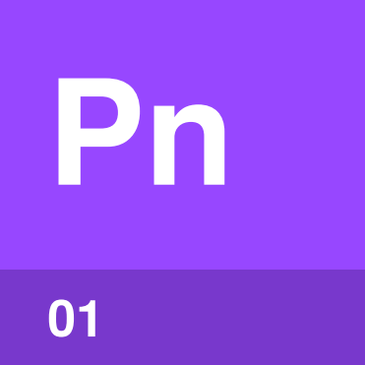 | Pin  page 3
 |  |  | 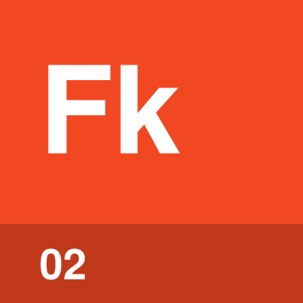 | Fork  page 4
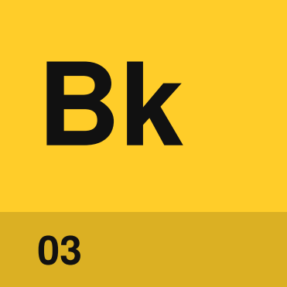 | Back-rank mate  page 5
 |  | 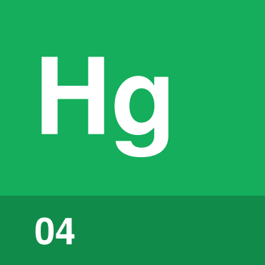 | Hanging piece  page 6
King in the center  page 7 |  |  |  | 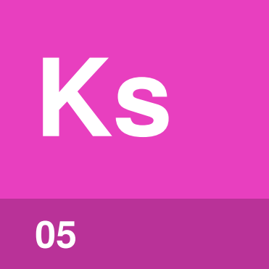

What are the
five problems?
Five problems turn up often in casual games. Each has a usual way out, and a habit that helps you avoid it next time.
Moves are written in algebraic notation, explained in An Accidental Guide to: The First Move in Chess. In 4…Bd7, the dots mark a move by Black. An x marks a capture and + marks check. Each board is drawn from the side in trouble.
Pin | A piece can’t move safely because a more valuable one is behind it.
Fork | One piece attacks two or more pieces at once.
Back-rank mate | A rook or queen mates a king shut in behind its own pawns.
Hanging piece | An unprotected piece is open to capture.
King in the center | A king that hasn’t castled when lines toward it open.

Pin | 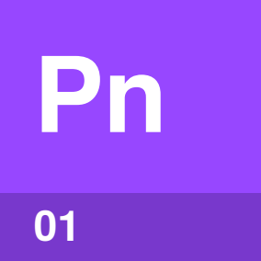

Identify by | A bishop, rook or queen lined up through your piece to a more valuable one.
What | A pin means a piece can’t move without exposing a more valuable piece behind it. The knight on c6 is pinned to the king, so it can’t move at all.
So what | Block the line with 4…Bd7. Other ways out are moving the king, or capturing or chasing the pinning piece.

Field marks
Way out  Block the line. | Next time  Check what is lined up.

Confused with | Relative pin  With the king behind, the pin is absolute. In a relative pin, the pinned piece may move, but the piece behind it can then be captured.

Fork | 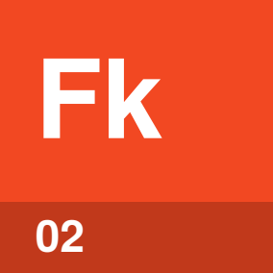

Identify by | One piece, often a knight, attacking two or more of yours.
What | A fork is one piece attacking two or more pieces at once. Knights fork well because no piece a knight attacks can capture it, except another knight.
So what | Capture the forking piece if you can, here with Qxc2. If you can’t, answer the check and expect to lose the rook.

Field marks
Way out  Capture the forking piece. | Next time  Watch enemy knight jumps.

Confused with |  Pin  A fork attacks two or more pieces at once. A pin stops one piece from moving safely.

Back-rank mate | 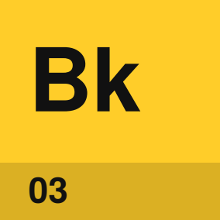

Identify by | Your king behind its own pawns, with an enemy rook or queen able to reach its rank.
What | A back-rank mate is checkmate by a rook or queen along the back rank, the row where the king started. The king’s own pawns block its escape.
So what | Make an escape square with h3, so the king can step to h2, or keep a rook or queen guarding the back rank.

Field marks
Way out  Give the king a square. | Next time  Guard the back rank.

Confused with | A safe castled king  Castling usually makes your king safer. The pawns that shelter it can also trap it on the back rank.

Hanging piece | 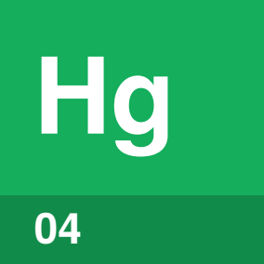

Identify by | A piece that nothing defends, with an enemy piece attacking it.
What | A hanging piece is unprotected and can be captured, like the knight on e5.
So what | Move the piece to a safe square or defend it. Here, move the knight back with 4.Nf3, because a pawn attacks it.

Field marks
Way out  Move it or defend it. | Next time  Check what is unprotected.

Confused with | En prise  En prise covers any piece that can be taken at a loss, including one with too few defenders or one attacked by a cheaper piece.

King in the center | 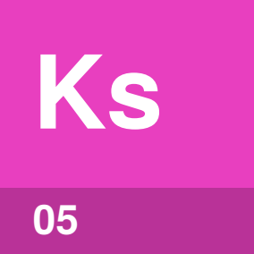

Identify by | Your king still on e1 or e8, with open lines toward it.
What | A king in the center is a king that hasn’t castled when lines toward it open. With the c-pawn and d-pawn gone, the bishop on b4 reaches e1.
So what | Block the check with 7.Bd2 or 7.Nc3, bringing a piece into play, then castle.

Field marks
Way out  Block, then castle. | Next time  Castle early.

Confused with | Castling out of check  You can’t castle while in check, or across or onto a square an enemy piece attacks.

Sources
These public sources were checked on 22 October 2026.
Wikipedia, Pin (chess)
May 2026 · en.wikipedia.org/wiki/Pin_(chess)
Wikipedia, Fork (chess)
July 2026 · en.wikipedia.org/wiki/Fork_(chess)
Wikipedia, Back-rank checkmate
May 2026 · en.wikipedia.org/wiki/Back-rank_checkmate
Wikipedia, Glossary of chess
October 2026 · en.wikipedia.org/wiki/Glossary_of_chess
Wikipedia, Giuoco Piano
September 2026 · en.wikipedia.org/wiki/Giuoco_Piano
Wikipedia, Ruy Lopez
October 2026 · en.wikipedia.org/wiki/Ruy_Lopez
Wikipedia, Petrov’s Defence
October 2026 · en.wikipedia.org/wiki/Petrov%27s_Defence
Chess.com, Chess Terms: Pin, Fork, Back-Rank Mate, Hanging Piece, Check, Castling
October 2026 · chess.com/terms


An Accidental Guide to…
Getting Out of Trouble in Chess
A pocket-sized guide to five common problem positions, and the clearest way out of each.
Written and reviewed by a person. AI does the grunt work. Set in TeX Gyre Heros and Newsreader.
Leave a star: accidental.info/star

