An Accidental Guide to… | Games 03 | 

The Last Move
in Chess
A pocket-sized guide to how a game of chess ends, and how to end one well.
 Runs | Written |  Checks | Used |  Decided |  Counted
 |  | 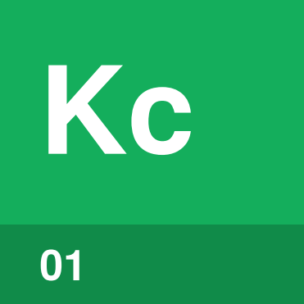 | Check  page 4
Checkmate  page 4 |  |  |  |  | 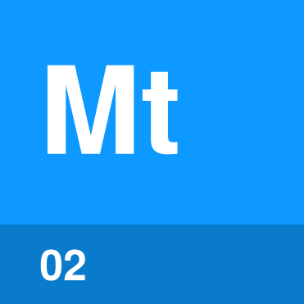
Stalemate  page 5 |  |  |  |  | 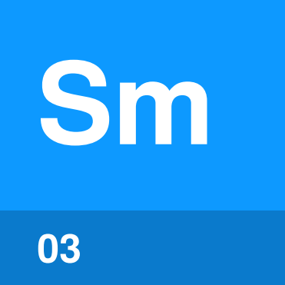
 |  |  |  | 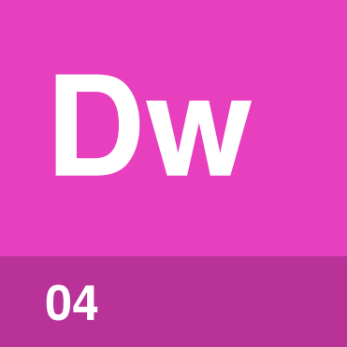 | Draw  page 6
 |  |  |  | 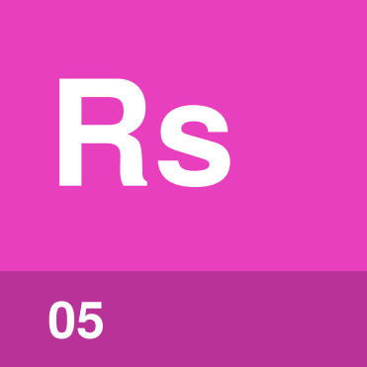 | Resigning  page 7

How does a
chess game end?
A chess game ends in a win or a draw. You win by checkmate, or when the other player resigns. With a clock, a player who runs out of time usually loses. A draw comes from agreement, stalemate or one of a few other rules.
A win scores one point, a draw half a point each and a loss nothing. The game ends as soon as checkmate, stalemate or a resignation happens, so nobody ever captures a king.
Check is the only one of these five that doesn’t end the game.
Check | A king is under attack, so its player must respond.
Checkmate | A king is in check with no legal way out.
Stalemate | The player to move has no legal move, but that player’s king isn’t in check.
Draw | The game ends without a winner.
Resigning | A player concedes the game.

Checkmate or
stalemate?
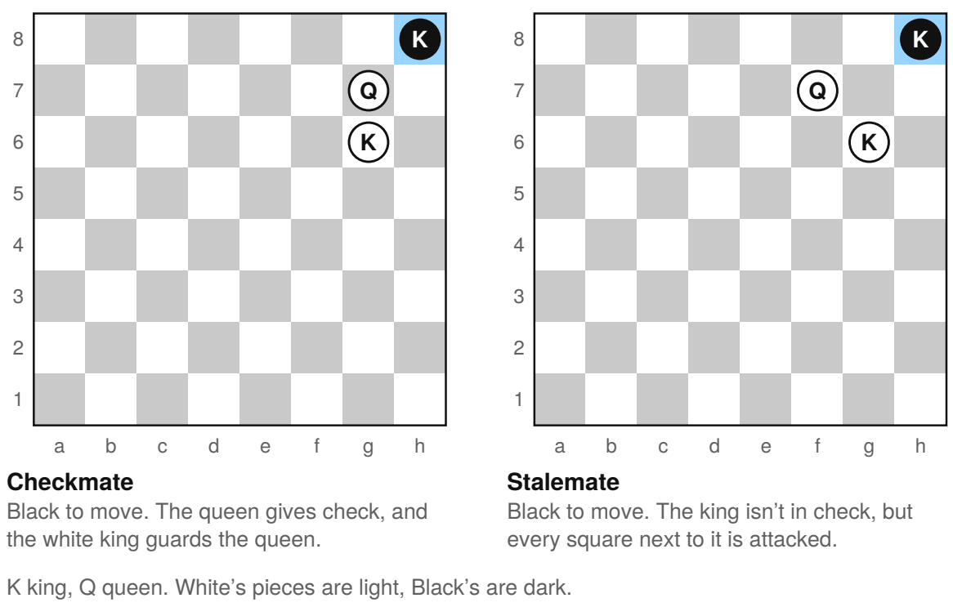
Black has no legal move on either board. On the left, that’s checkmate and White wins. On the right, it’s stalemate and the game is a draw. When you’re winning, leave your opponent a legal move unless your move is checkmate.

Check | 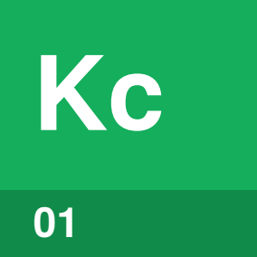

Identify by | A piece attacking a king, or a + written after the move.
What | Check means the king is attacked by an enemy piece.
So what | You must get out of check at once: move the king, block the attack or capture the attacker. No move may leave your own king in check.

Field marks
Result  The game goes on. | Decided by  The position after the move.

Confused with |  Checkmate  Check means the king is attacked. Checkmate means there is no legal way to stop the attack.

Checkmate | 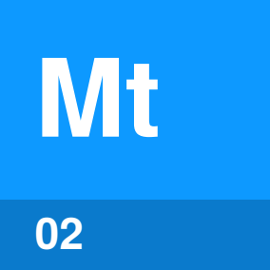

Identify by | The king in check, with no legal move that gets out.
What | Checkmate is check with no legal way out. None of the three ways out of check works.
So what | Checkmate ends the game at once. The player who gave checkmate wins, and # after the move records it.

Field marks
Result  A win. | Decided by  The checkmating move.

Confused with |  Stalemate  Checkmate requires the king to be in check. In stalemate, the king isn’t in check, but its player has no legal move.

Stalemate | 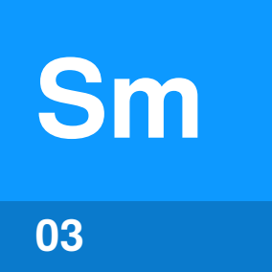

Identify by | Your turn, your king not in check and no legal move.
What | Stalemate is a position where the player to move has no legal move and isn’t in check.
So what | Stalemate makes the game a draw, however many pieces the other side has.

Field marks
Result  A draw. | Decided by  The position.

Confused with | Any draw  Stalemate is one kind of draw. Not every draw is a stalemate.

Draw | 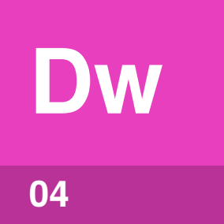

Identify by | A draw offer after a move, or the same position for the third time.
What | A draw is a game that ends without a winner. A draw comes from agreement, stalemate, a position where nobody can checkmate, or a claim after repetition or fifty moves each without a pawn move or capture.
So what | The same position three times lets the player to move claim a draw. Under FIDE rules, five times ends the game in a draw.

Field marks
Result  Half a point each. | Decided by  The rules or both players.

Confused with | A handshake  A handshake alone doesn’t state the result. One player may take it as a draw and the other as a resignation, so say the result in words.

Resigning | 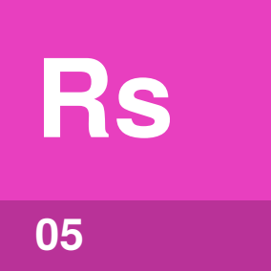

Identify by | “I resign” said aloud, or a king tipped over.
What | Resigning means giving up the game, which ends at once.
So what | The other player wins when you resign. Under FIDE rules, if the other player couldn’t possibly checkmate, it’s a draw instead.

Field marks
Result  A loss, usually. | Decided by  The player resigning.

Confused with | Stopping the clock  Stopping both clocks doesn’t necessarily mean a player has resigned. Ask before you treat the game as over.

How do you
finish politely?
A few habits prevent confusion at the end.
Touch only the intended piece | Touch your own piece and you must move it. Touch an opponent’s piece and you must take it, if you can.
Say “I adjust” first | On your turn, say it before you straighten a piece, so your opponent knows you aren’t moving it.
Offer a draw after moving | Make your move, offer the draw, then press your clock if you have one. The offer stands until your opponent accepts, says no or touches a piece.
Resign clearly | Say “I resign” or tip over your king, so the result is clear.
Shake hands before and after | A handshake shows respect. Words make the result clear.
Put the pieces back | Return each piece to its starting square.

After the handshake, share your thoughts about the game, whatever the result.

Sources
These public sources were checked on 22 October 2026.
FIDE, Laws of Chess
January 2023 · handbook.fide.com/chapter/E012023
US Chess, Official Rules of Chess, 7th edition (free chapters)
January 2026 · new.uschess.org/sites/default/files/media/documents/us-chess-rule-book-online-2026.pdf
FIDE, Curriculum: Chess for Refugees
October 2023 · fide.com/docs/presentations/Curriculum%20Chess%20for%20Refugees.pdf
US Chess, Guide to Scholastic Chess, 11th edition
June 2021 · new.uschess.org/sites/default/files/media/documents/11th-edition-guide-to-scholastic-chess-6-29-21.pdf

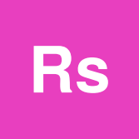
An Accidental Guide to…
The Last Move in Chess
A pocket-sized guide to how a game of chess ends, and how to end one well.
Written and reviewed by a person. AI does the grunt work. Set in TeX Gyre Heros and Newsreader.
Leave a star: accidental.info/star

