An Accidental Guide to… | Games 02 | 

The First Move
in Chess
A pocket-sized guide to what to play first, as White or as Black.
 Runs |  Written | Checks |  Used | Decided | Counted
 |  |  |  | Center  page 4
 | Development  page 5
 | Castling  page 6

What should your
first move be?
White moves first, then the players take turns. Start with a pawn in the middle of the board, bring out your knights and bishops, then castle to put your king somewhere safer. You don’t need to memorize a string of moves.
The first few moves have two jobs: get your pieces into the game quickly and get your king safe. When you’re learning, a few principles help more than memorized sequences of moves, because they work against whatever the other player does.
Center, development and castling cover most of what you need at the start.
Center | The four squares in the middle of the board.
Development | Moving knights and bishops out so they can take part.
Castling | One move of your king and a rook together.

How do you
read the board?
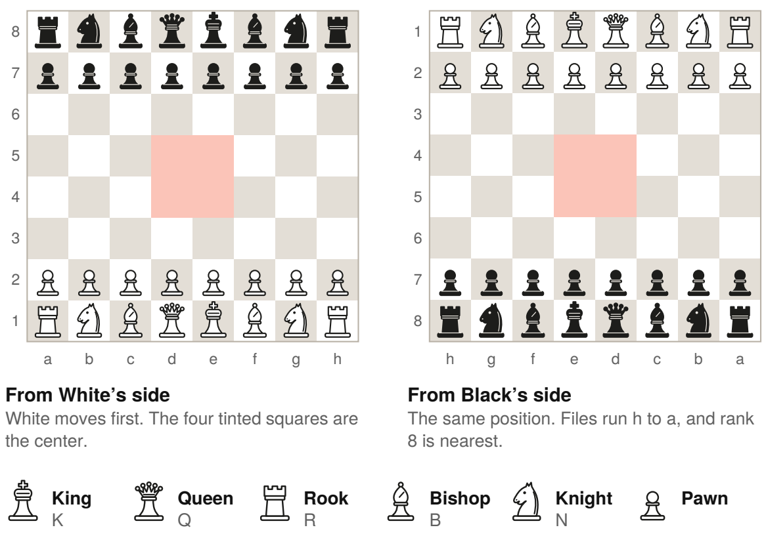
Each square has a letter and a number. From White’s side, the columns, called files, run from a to h, left to right. The rows, called ranks, run from 1 to 8, going away from White. Set it down so each player has a light square in the near right corner.
Pieces use K for king, Q for queen, R for rook, B for bishop and N for knight. A pawn move is written as the square it lands on. Moves are numbered with White first, so 1.e4 e5 means White’s pawn goes to e4, then Black’s pawn goes to e5. Black’s move alone is 1…e5. An x means a capture, and # means checkmate.

Center | 

Identify by | The four middle squares, d4, d5, e4 and e5.
What | The center is the four squares in the middle of the board. Start by moving the pawn in front of your king or queen two squares into it.
So what | A center pawn move frees your queen and a bishop to move. The center usually opens first, because center pawns often capture each other.

Field marks
When  On your first move. | Aim  A pawn in the middle. | Mistake  Too many pawn moves.

Confused with | Pawn moves  One or two center pawn moves help your pieces get out. Too many early pawn moves leave your knights and bishops at home.

Development | 

Identify by | Knights and bishops leaving their starting squares.
What | Development is moving your knights and bishops out so they can take part. Try to move each piece once before moving it again.
So what | A lead in development gives you more pieces in the game than your opponent. Your opponent is trying to bring pieces out too.

Field marks
When  After a center pawn. | Aim  Knights and bishops out. | Mistake  Moving one piece twice.

Confused with | Bringing out the queen  Bring your queen out after your knights and bishops. An early queen can be chased by knights and bishops that your opponent wanted to develop anyway.

Castling | 

Identify by | The king moves two squares and a rook moves past it.
What | Castling is one move of the king and a rook, written 0-0 on the king’s side or 0-0-0 on the queen’s side. The king moves two squares toward the rook, then the rook lands on the square the king crossed.
So what | Castling moves your king away from the center and brings a rook toward it. Castle early, after moving the pieces between your king and rook.

Field marks
When  Early in the game. | Aim  A safer king. | Mistake  Waiting too long.

Confused with | Moving the king  An ordinary king move goes one square. To castle, neither the king nor that rook may have moved, and no piece can stand between them. The king can’t castle out of check, and it can’t cross or land on a square an enemy piece attacks. Move the king first, then the rook.

What do you play,
as White or Black?
Pick the row for your color and the last move played.
1.e4 | As White. The e-pawn moves two squares and frees the queen and a bishop to move.
1.d4 | As White. The same idea with the d-pawn.
1…e5 | As Black, after 1.e4. The e-pawn moves two squares, blocks White’s e-pawn and frees the queen and a bishop to move.
1…d5 | As Black, after 1.d4. The same idea with the d-pawn.
2.Nf3 Nc6 | White’s knight goes to f3 and Black’s knight goes to c6. Bishops come next. Each move brings one piece into the game.
0-0 | Castle on the king’s side once the knight and bishop between king and rook have moved.

Watch out. White’s queen and bishop can both attack f7, which only Black’s king defends at the start. The game 1.e4 e5 2.Bc4 Bc5 3.Qh5 Nf6 4.Qxf7# ends in checkmate. As Black, when White’s queen and bishop both aim at f7, defend f7 on your next move. Here, 3…Qe7 does it.

Then keep bringing out pieces you haven’t moved yet.

Sources
These public sources were checked on 22 October 2026.
FIDE, Laws of Chess
January 2023 · handbook.fide.com/chapter/E012023
FIDE, Curriculum: Chess for Refugees
October 2023 · fide.com/docs/presentations/Curriculum%20Chess%20for%20Refugees.pdf
US Chess, Guide to Scholastic Chess, 11th edition
June 2021 · new.uschess.org/sites/default/files/media/documents/11th-edition-guide-to-scholastic-chess-6-29-21.pdf
Wikipedia, List of ECO codes and each opening’s article
October 2026 · en.wikipedia.org/wiki/List_of_ECO_codes
Lichess, opening explorer
October 2026 · lichess.org/opening


An Accidental Guide to…
The First Move in Chess
A pocket-sized guide to what to play first, as White or as Black.
Written and reviewed by a person. AI does the grunt work. Set in TeX Gyre Heros and Newsreader.
Leave a star: accidental.info/star

