An Accidental Guide to… | Accidental Intelligence 00 | 

Accidental
Intelligence
A pocket-sized guide to the Accidental Guides, as of October 2026.
 Runs |  Written |  Checks |  Used |  Decided |  Counted
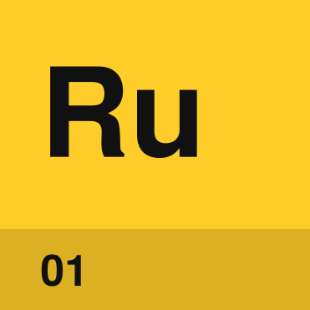 | Things that run  7 parts
 | 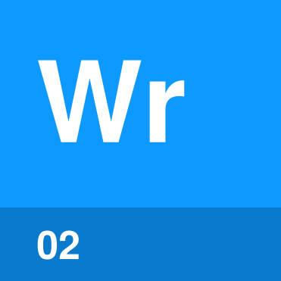 | Things you write down  6 parts
 |  | 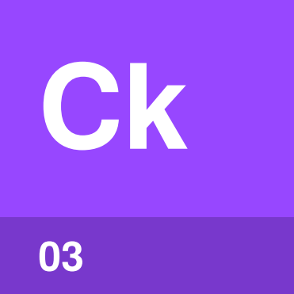 | Things that check  7 parts
 |  |  | 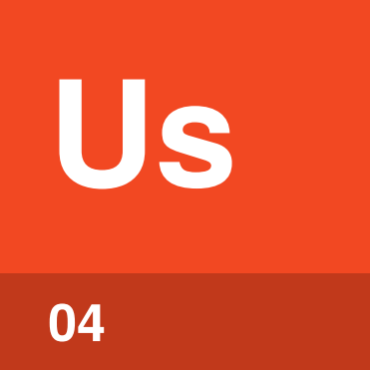 | Things an agent uses  4 parts
Decisions people make  5 parts |  |  |  | 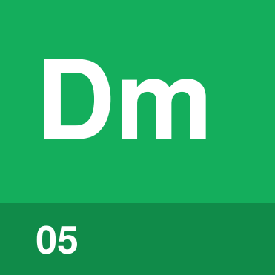
Numbers and claims  7 parts |  |  |  |  | 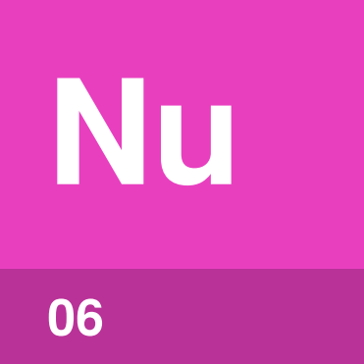

What are the
Accidental Guides?
The Accidental Guides are short guides to AI coding agents and the ways teams use them to build software. Each one answers one question by explaining a few parts, one at a time.
There’s a lot written about AI coding agents, and the same word often means different things to different writers. These guides are short and use one name for each thing in every guide, so what you learn in one carries over to the next.
The guides started by accident, when one was written to settle which words to use for the parts of a coding agent. The title Accidental Intelligence plays on artificial intelligence.
People often build a machine for one job and find it does another. The models that coding agents use were trained to predict the next word, and it turned out they could write software. Guides that started by accident are in good company.
Guide | Answers | Version
Agents, Harnesses, Skills, and Tools | What are the parts of an AI coding agent, and what does each one do? | 1.0.0
Specs and Reviews | How does work get from an idea to done? | 0.2.0
Software Factories | What is a software factory, and what’s in one? | 0.1.0
Lights-Off Software Factories | What decides if a change is right when nobody reads the code? | 0.2.0
Harness Engineering | What do teams build to catch a coding agent’s mistakes? | 0.1.0 draft
Running a Software Factory | What does a team decide before a factory runs, and how does it know the factory works? | 0.1.0 draft
Software Factory Claims | How do you check a claim about AI-built software? | 0.1.0 draft

Where do I start?
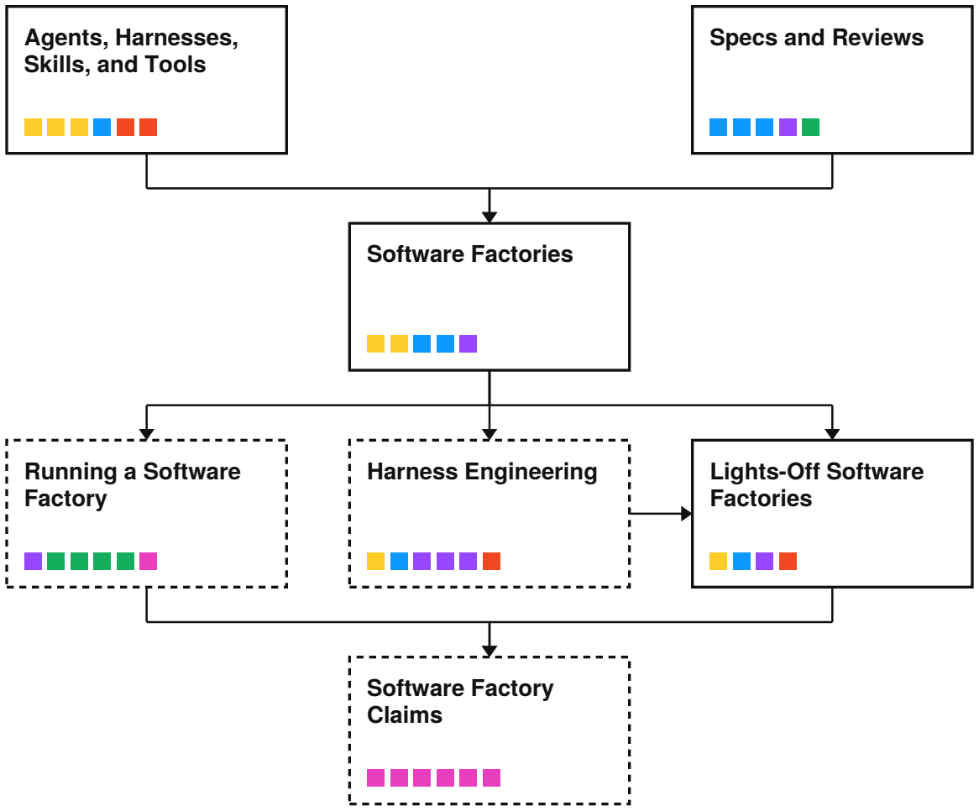
Arrows show the order to read the guides in. A dashed box is a draft. The small squares are each guide’s parts, colored by family.
Guide | Read it if you
Agents, Harnesses, Skills, and Tools | use a coding agent and want to know how it works
Specs and Reviews | are new to specs, trackers and reviews
Software Factories | hear “software factory” and want to know what it means
Running a Software Factory | lead a team that runs a factory
Harness Engineering | build checks and limits for coding agents
Lights-Off Software Factories | wonder if anyone still needs to read the code
Software Factory Claims | read announcements about AI writing code

What do the colors mean?
Each part belongs to one of six families, and each family has one color.
A part goes in the family of the job it does. A review agent runs, but its job is to judge a change, so it sits with the checks.
 | Things that run  Programs and loops that do the work.  Model, Harness, Agent, Orchestrator, Agent session, Closed loop, Outer loop
 | Things you write down  Text that people or agents read and keep.  Skill, Spec, Work item, Tracker, Scenario, Progress file
 | Things that check  Whatever decides if a change is right.  Review, Gate, Satisfaction, Check, Review agent, Eval, Evidence
 | Things an agent uses  Tools an agent calls and places it works in.  Tool, MCP server, Digital twin, Sandbox
 | Decisions people make  Rules a team sets before the work runs.  Acceptance criteria, Accepted output, Boundary, Identity, Back pressure
 | Numbers and claims  Counts and scores, and the claims built on them.  Metric, Share of code, Multiplier, Benchmark, Demo, Headcount, Dark factory

Inside each guide, tiles are colored by their order in that guide, so a part may have a different color there.

Where does each part live?
Each row is one guide and the parts it defines, sorted by color.
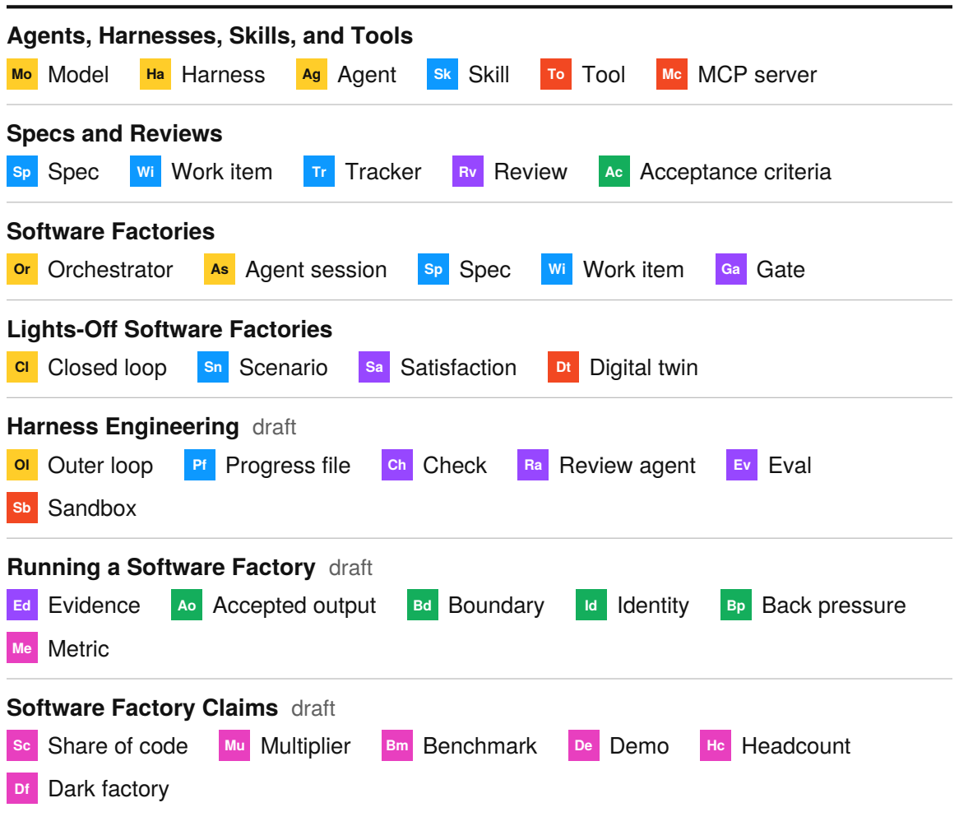
Spec and work item are parts in two guides, once for any project and once inside a factory.

Guides to start with

Agents, Harnesses, Skills, and Tools version 1.0.0
Parts | Model, Harness, Agent, Skill, Tool, MCP server
Read next | Software Factories, where a program starts the agent sessions instead of you.

Specs and Reviews version 0.2.0
Parts | Spec, Work item, Tracker, Acceptance criteria, Review
Read next | Software Factories.

Software Factories version 0.1.0
Parts | Spec, Work item, Orchestrator, Agent session, Gate
Read next | Running a Software Factory if you lead one, Harness Engineering if you build one, and Lights-Off Software Factories if you wonder whether anyone needs to read the code.

Guides to read next

Lights-Off Software Factories version 0.2.0
Parts | Scenario, Digital twin, Satisfaction, Closed loop
Read next | Software Factory Claims.

Harness Engineering version 0.1.0 draft
Parts | Check, Review agent, Eval, Outer loop, Progress file, Sandbox
Read next | Lights-Off Software Factories, for the checks you need before you stop reading the code.

Running a Software Factory version 0.1.0 draft
Parts | Accepted output, Boundary, Identity, Evidence, Back pressure, Metric
Read next | Software Factory Claims, for checking the numbers other people publish.

Software Factory Claims version 0.1.0 draft
Parts | Share of code, Multiplier, Benchmark, Demo, Headcount, Dark factory
Read next | Lights-Off Software Factories, since the boldest claims are about factories where nobody reads the code.

Versions
The version number on each guide’s cover goes up whenever the text changes. Before 1.0.0, a guide’s parts may still change.


An Accidental Guide to…
Accidental Intelligence
A pocket-sized guide to the Accidental Guides, as of October 2026.
Written and reviewed by a person. AI does the grunt work. Set in TeX Gyre Heros and Newsreader.
Leave a star: accidental.info/star

