An Accidental Guide to… | Your collection 01 | 

Your
Topic
A pocket-sized guide to the one question your reader has, in one line.
 Runs |  Written |  Checks |  Used |  Decided |  Counted
Part one  page 4 |  |  |  |  | 
 | 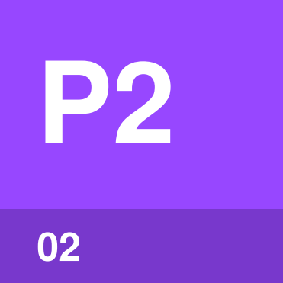 | Part two  page 5
 |  | 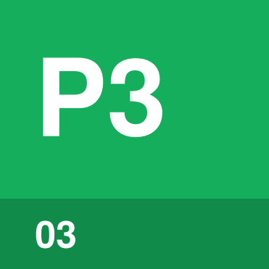 | Part three  page 6
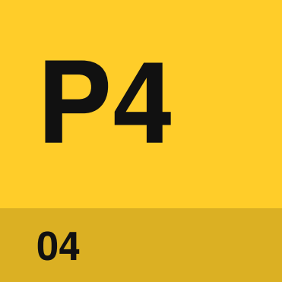 | Part four  page 7
 |  |  | 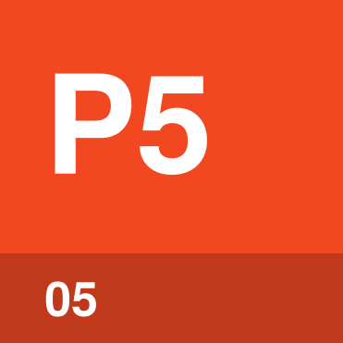 | Part five  page 8
 |  |  |  | 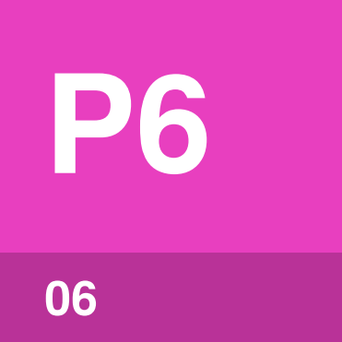 | Part six  page 9

The question your
reader is asking
Put the reader’s question in the page title, in their words. Then answer it in two or three short paragraphs: what the thing is, and why anyone would want to know.
Write for someone clever who has never done this before and would quite like to get it over with. Use plain words and short sentences. A joke is welcome if it turns up on its own. Don’t go looking for one.
Finish by naming the parts. Six is the most. Four is fine. Give each one name and use that name every time.
Part one | One line: what the part is.
Part two | One line: what the part is.
Part three | One line: what the part is.
Part four | One line: what the part is.
Part five | One line: what the part is.
Part six | One line: what the part is.

How do the parts
fit together?
Walk through the parts in the order the reader meets them, in two or three paragraphs. Use each part’s name exactly as its own page has it.
If a diagram would help, describe it in a few sentences: what the boxes are and what the arrows mean. The diagram gets drawn when the guide is built.
Tip. One practical tip or warning on a page, at most. Delete this box if you don’t have one.

Part one | 

Identify by | One line: how the reader recognizes the part when they meet it.
What | What the part is, in one sentence. Then a sentence or two more, if the reader needs them.
So what | Why the reader should care, in one sentence. Then what they do differently because of it.

Field marks
When  A short answer first. When the reader meets the part. Change the labels to suit your topic, and use the same ones for every part. | Who  Two to five words. Who does it, brings it or is in charge of it. | Takes  A time or an amount. How long it lasts, or what it costs.
Needs  What has to be ready. Anything the reader must have first. | Can  What it does well. One concrete example. | Cannot  What it won’t do. The mistake people make by expecting it to.

Confused with | Something else  Name the thing people mix this part up with. Then say, in a sentence each, how to tell the two apart.

Part two | 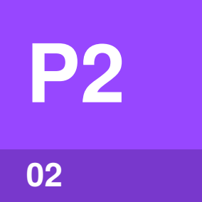

Identify by | How the reader recognizes the part.
What | What the part is, in one sentence. Then a sentence or two more.
So what | Why the reader should care, in one sentence. Then what changes for them.

Field marks
When  Short answer. One sentence. | Who  Short answer. One sentence. | Takes  Short answer. One sentence.
Needs  Short answer. One sentence. | Can  Short answer. One example. | Cannot  Short answer. One example.

Confused with | Something else  What it gets mixed up with, and how to tell them apart.

Part three | 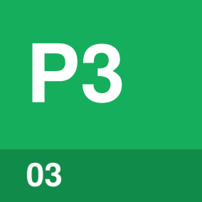

Identify by | How the reader recognizes the part.
What | What the part is, in one sentence. Then a sentence or two more.
So what | Why the reader should care, in one sentence. Then what changes for them.

Field marks
When  Short answer. One sentence. | Who  Short answer. One sentence. | Takes  Short answer. One sentence.
Needs  Short answer. One sentence. | Can  Short answer. One example. | Cannot  Short answer. One example.

Confused with | Something else  What it gets mixed up with, and how to tell them apart.

Part four | 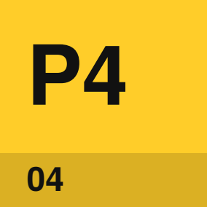

Identify by | How the reader recognizes the part.
What | What the part is, in one sentence. Then a sentence or two more.
So what | Why the reader should care, in one sentence. Then what changes for them.

Field marks
When  Short answer. One sentence. | Who  Short answer. One sentence. | Takes  Short answer. One sentence.
Needs  Short answer. One sentence. | Can  Short answer. One example. | Cannot  Short answer. One example.

Confused with | Something else  What it gets mixed up with, and how to tell them apart.

Part five | 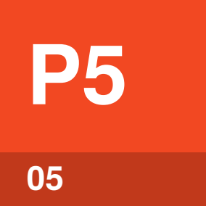

Identify by | How the reader recognizes the part.
What | What the part is, in one sentence. Then a sentence or two more.
So what | Why the reader should care, in one sentence. Then what changes for them.

Field marks
When  Short answer. One sentence. | Who  Short answer. One sentence. | Takes  Short answer. One sentence.
Needs  Short answer. One sentence. | Can  Short answer. One example. | Cannot  Short answer. One example.

Confused with | Something else  What it gets mixed up with, and how to tell them apart.

Part six | 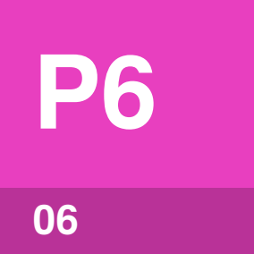

Identify by | How the reader recognizes the part.
What | Six parts is the limit. Delete the parts you don’t need, and the matching rows on the first page.
So what | Six parts keeps the guide to about five minutes of reading. Past that, the reader starts to forget part one.

Field marks
When  Short answer. One sentence. | Who  Short answer. One sentence. | Takes  Short answer. One sentence.
Needs  Short answer. One sentence. | Can  Short answer. One example. | Cannot  Short answer. One example.

Confused with | Something else  What it gets mixed up with, and how to tell them apart.

Sources
List every source you used, and only sources you have read yourself. Each fact in the text should come from one of them.
Author, Title of the page
Month Year · example.com/page
Author, Title of the book
Year · Publisher, page 12
Organization, Title of the guidance
Month Year · example.org/guidance


An Accidental Guide to…
Your Topic
A pocket-sized guide to the one question your reader has, in one line.
Written and reviewed by a person. AI does the grunt work. Set in TeX Gyre Heros and Newsreader.
Leave a star: accidental.info/star

